**College Admission.**

Q1) Find the missing values. (if any, perform missing value treatment)

Ans) The below attached is the code in R,which gives an overview of the missing values

college_data<-read.csv("https://raw.githubusercontent.com/shivanipriya89/College/main/College.csv")

print(college_data)

View(college_data)

missing<-is.na(college_data)

missing

which(is.na(missing))

sum(is.na(missing))

Here,is the output of code mention above. The first screenshot represents the tabular format of college admission details

admit gre gpa ses Gender_Male Race rank

1 0 380 3.61 1 0 3 3

2 1 660 3.67 2 0 2 3

3 1 800 4.00 2 0 2 1

4 1 640 3.19 1 1 2 4

5 0 520 2.93 3 1 2 4

6 1 760 3.00 2 1 1 2

7 1 560 2.98 2 1 2 1

8 0 400 3.08 2 0 2 2

9 1 540 3.39 1 1 1 3

10 0 700 3.92 1 0 2 2

11 0 800 4.00 1 1 1 4

12 0 440 3.22 3 0 2 1

13 1 760 4.00 3 1 2 1

14 0 700 3.08 2 0 2 2

15 1 700 4.00 2 1 1 1

16 0 480 3.44 3 0 1 3

17 0 780 3.87 2 0 3 4

18 0 360 2.56 3 1 3 3

19 0 800 3.75 1 1 3 2

20 1 540 3.81 1 0 3 1

21 0 500 3.17 3 0 2 3

22 1 660 3.63 1 0 1 2

23 0 600 2.82 1 0 3 4

24 0 680 3.19 1 0 1 4

25 1 760 3.35 2 0 2 2

26 1 800 3.66 2 1 1 1

27 1 620 3.61 2 0 1 1

28 1 520 3.74 2 0 3 4

29 1 780 3.22 1 0 1 2

30 0 520 3.29 1 0 1 1

31 0 540 3.78 1 1 1 4

32 0 760 3.35 2 1 1 3

33 0 600 3.40 3 0 1 3

34 1 800 4.00 3 0 1 3

35 0 360 3.14 1 1 2 1

36 0 400 3.05 3 0 2 2

37 0 580 3.25 1 0 2 1

38 0 520 2.90 2 0 2 3

39 1 500 3.13 2 0 2 2

40 1 520 2.68 2 0 1 3

41 0 560 2.42 1 1 3 2

42 1 580 3.32 1 0 1 2

43 1 600 3.15 2 1 1 2

44 0 500 3.31 2 0 2 3

45 0 700 2.94 1 0 3 2

46 1 460 3.45 2 1 3 3

47 1 580 3.46 3 1 1 2

48 0 500 2.97 3 0 2 4

49 0 440 2.48 3 0 3 4

50 0 400 3.35 3 0 1 3

51 0 640 3.86 2 1 3 3

52 0 440 3.13 2 0 2 4

53 0 740 3.37 2 1 3 4

54 1 680 3.27 2 0 2 2

55 0 660 3.34 1 0 1 3

56 1 740 4.00 1 1 2 3

57 0 560 3.19 3 1 1 3

58 0 380 2.94 3 0 2 3

59 0 400 3.65 3 1 2 2

60 0 600 2.82 3 1 1 4

61 1 620 3.18 2 1 1 2

62 0 560 3.32 1 0 3 4

63 0 640 3.67 1 1 2 3

64 1 680 3.85 1 1 3 3

65 0 580 4.00 2 1 3 3

66 0 600 3.59 1 0 1 2

67 0 740 3.62 3 1 2 4

68 0 620 3.30 2 1 3 1

69 0 580 3.69 3 0 3 1

70 0 800 3.73 1 1 1 1

71 0 640 4.00 1 1 1 3

72 0 300 2.92 1 1 1 4

73 0 480 3.39 2 0 2 4

74 0 580 4.00 3 0 3 2

75 0 720 3.45 2 1 2 4

76 0 720 4.00 2 0 3 3

77 0 560 3.36 1 1 2 3

78 1 800 4.00 3 0 3 3

79 0 540 3.12 3 1 2 1

80 1 620 4.00 2 0 2 1

81 0 700 2.90 2 0 2 4

82 0 620 3.07 3 1 2 2

83 0 500 2.71 2 0 3 2

84 0 380 2.91 3 1 2 4

85 1 500 3.60 1 1 1 3

86 0 520 2.98 2 0 2 2

87 0 600 3.32 1 0 3 2

88 0 600 3.48 1 0 1 2

89 0 700 3.28 3 0 3 1

90 1 660 4.00 1 1 1 2

91 0 700 3.83 2 0 2 2

92 1 720 3.64 2 0 2 1

93 0 800 3.90 3 1 1 2

94 0 580 2.93 3 1 1 2

95 1 660 3.44 2 0 3 2

96 0 660 3.33 2 1 3 2

97 0 640 3.52 2 1 3 4

98 0 480 3.57 3 1 2 2

99 0 700 2.88 2 1 3 2

100 0 400 3.31 3 1 2 3

101 0 340 3.15 2 0 1 3

102 0 580 3.57 1 1 2 3

103 0 380 3.33 3 0 3 4

104 0 540 3.94 3 0 1 3

105 1 660 3.95 2 1 1 2

106 1 740 2.97 1 1 1 2

107 1 700 3.56 1 1 2 1

108 0 480 3.13 2 0 1 2

109 0 400 2.93 1 1 3 3

110 0 480 3.45 3 0 1 2

111 0 680 3.08 3 0 3 4

112 0 420 3.41 2 1 3 4

113 0 360 3.00 1 0 1 3

114 0 600 3.22 3 1 2 1

115 0 720 3.84 1 1 2 3

116 0 620 3.99 2 1 2 3

117 1 440 3.45 1 1 3 2

118 0 700 3.72 2 1 2 2

119 1 800 3.70 1 0 2 1

120 0 340 2.92 3 1 2 3

121 1 520 3.74 2 0 2 2

122 1 480 2.67 1 0 1 2

123 0 520 2.85 3 0 1 3

124 0 500 2.98 3 0 2 3

125 0 720 3.88 2 0 3 3

126 0 540 3.38 3 0 3 4

127 1 600 3.54 3 0 3 1

128 0 740 3.74 1 0 3 4

129 0 540 3.19 1 1 3 2

130 0 460 3.15 3 0 2 4

131 1 620 3.17 1 0 3 2

132 0 640 2.79 3 1 1 2

133 0 580 3.40 3 0 1 2

134 0 500 3.08 2 1 2 3

135 0 560 2.95 3 1 1 2

136 0 500 3.57 2 1 3 3

137 0 560 3.33 3 1 2 4

138 0 700 4.00 3 1 1 3

139 0 620 3.40 3 0 1 2

140 1 600 3.58 3 0 3 1

141 0 640 3.93 2 1 2 2

142 1 700 3.52 2 0 1 4

> missing<-is.na(college_data)

> missing

admit gre gpa ses Gender_Male Race rank

[1,] FALSE FALSE FALSE FALSE FALSE FALSE FALSE

[2,] FALSE FALSE FALSE FALSE FALSE FALSE FALSE

[3,] FALSE FALSE FALSE FALSE FALSE FALSE FALSE

[4,] FALSE FALSE FALSE FALSE FALSE FALSE FALSE

[5,] FALSE FALSE FALSE FALSE FALSE FALSE FALSE

[6,] FALSE FALSE FALSE FALSE FALSE FALSE FALSE

[7,] FALSE FALSE FALSE FALSE FALSE FALSE FALSE

[8,] FALSE FALSE FALSE FALSE FALSE FALSE FALSE

[9,] FALSE FALSE FALSE FALSE FALSE FALSE FALSE

[10,] FALSE FALSE FALSE FALSE FALSE FALSE FALSE

[11,] FALSE FALSE FALSE FALSE FALSE FALSE FALSE

[12,] FALSE FALSE FALSE FALSE FALSE FALSE FALSE

[13,] FALSE FALSE FALSE FALSE FALSE FALSE FALSE

[14,] FALSE FALSE FALSE FALSE FALSE FALSE FALSE

[15,] FALSE FALSE FALSE FALSE FALSE FALSE FALSE

[16,] FALSE FALSE FALSE FALSE FALSE FALSE FALSE

[17,] FALSE FALSE FALSE FALSE FALSE FALSE FALSE

[18,] FALSE FALSE FALSE FALSE FALSE FALSE FALSE

[19,] FALSE FALSE FALSE FALSE FALSE FALSE FALSE

[20,] FALSE FALSE FALSE FALSE FALSE FALSE FALSE

[21,] FALSE FALSE FALSE FALSE FALSE FALSE FALSE

[22,] FALSE FALSE FALSE FALSE FALSE FALSE FALSE

[23,] FALSE FALSE FALSE FALSE FALSE FALSE FALSE

[24,] FALSE FALSE FALSE FALSE FALSE FALSE FALSE

[25,] FALSE FALSE FALSE FALSE FALSE FALSE FALSE

[26,] FALSE FALSE FALSE FALSE FALSE FALSE FALSE

[27,] FALSE FALSE FALSE FALSE FALSE FALSE FALSE

[28,] FALSE FALSE FALSE FALSE FALSE FALSE FALSE

[29,] FALSE FALSE FALSE FALSE FALSE FALSE FALSE

[30,] FALSE FALSE FALSE FALSE FALSE FALSE FALSE

[31,] FALSE FALSE FALSE FALSE FALSE FALSE FALSE

[32,] FALSE FALSE FALSE FALSE FALSE FALSE FALSE

[33,] FALSE FALSE FALSE FALSE FALSE FALSE FALSE

[34,] FALSE FALSE FALSE FALSE FALSE FALSE FALSE

[35,] FALSE FALSE FALSE FALSE FALSE FALSE FALSE

[36,] FALSE FALSE FALSE FALSE FALSE FALSE FALSE

[37,] FALSE FALSE FALSE FALSE FALSE FALSE FALSE

[38,] FALSE FALSE FALSE FALSE FALSE FALSE FALSE

[39,] FALSE FALSE FALSE FALSE FALSE FALSE FALSE

[40,] FALSE FALSE FALSE FALSE FALSE FALSE FALSE

[41,] FALSE FALSE FALSE FALSE FALSE FALSE FALSE

[42,] FALSE FALSE FALSE FALSE FALSE FALSE FALSE

[43,] FALSE FALSE FALSE FALSE FALSE FALSE FALSE

[44,] FALSE FALSE FALSE FALSE FALSE FALSE FALSE

[45,] FALSE FALSE FALSE FALSE FALSE FALSE FALSE

[46,] FALSE FALSE FALSE FALSE FALSE FALSE FALSE

[47,] FALSE FALSE FALSE FALSE FALSE FALSE FALSE

[48,] FALSE FALSE FALSE FALSE FALSE FALSE FALSE

[49,] FALSE FALSE FALSE FALSE FALSE FALSE FALSE

[50,] FALSE FALSE FALSE FALSE FALSE FALSE FALSE

[51,] FALSE FALSE FALSE FALSE FALSE FALSE FALSE

[52,] FALSE FALSE FALSE FALSE FALSE FALSE FALSE

[53,] FALSE FALSE FALSE FALSE FALSE FALSE FALSE

[54,] FALSE FALSE FALSE FALSE FALSE FALSE FALSE

[55,] FALSE FALSE FALSE FALSE FALSE FALSE FALSE

[56,] FALSE FALSE FALSE FALSE FALSE FALSE FALSE

[57,] FALSE FALSE FALSE FALSE FALSE FALSE FALSE

[58,] FALSE FALSE FALSE FALSE FALSE FALSE FALSE

[59,] FALSE FALSE FALSE FALSE FALSE FALSE FALSE

[60,] FALSE FALSE FALSE FALSE FALSE FALSE FALSE

[61,] FALSE FALSE FALSE FALSE FALSE FALSE FALSE

[62,] FALSE FALSE FALSE FALSE FALSE FALSE FALSE

[63,] FALSE FALSE FALSE FALSE FALSE FALSE FALSE

[64,] FALSE FALSE FALSE FALSE FALSE FALSE FALSE

[65,] FALSE FALSE FALSE FALSE FALSE FALSE FALSE

[66,] FALSE FALSE FALSE FALSE FALSE FALSE FALSE

[67,] FALSE FALSE FALSE FALSE FALSE FALSE FALSE

[68,] FALSE FALSE FALSE FALSE FALSE FALSE FALSE

[69,] FALSE FALSE FALSE FALSE FALSE FALSE FALSE

[70,] FALSE FALSE FALSE FALSE FALSE FALSE FALSE

[71,] FALSE FALSE FALSE FALSE FALSE FALSE FALSE

[72,] FALSE FALSE FALSE FALSE FALSE FALSE FALSE

[73,] FALSE FALSE FALSE FALSE FALSE FALSE FALSE

[74,] FALSE FALSE FALSE FALSE FALSE FALSE FALSE

[75,] FALSE FALSE FALSE FALSE FALSE FALSE FALSE

[76,] FALSE FALSE FALSE FALSE FALSE FALSE FALSE

[77,] FALSE FALSE FALSE FALSE FALSE FALSE FALSE

[78,] FALSE FALSE FALSE FALSE FALSE FALSE FALSE

[79,] FALSE FALSE FALSE FALSE FALSE FALSE FALSE

[80,] FALSE FALSE FALSE FALSE FALSE FALSE FALSE

[81,] FALSE FALSE FALSE FALSE FALSE FALSE FALSE

[82,] FALSE FALSE FALSE FALSE FALSE FALSE FALSE

[83,] FALSE FALSE FALSE FALSE FALSE FALSE FALSE

[84,] FALSE FALSE FALSE FALSE FALSE FALSE FALSE

[85,] FALSE FALSE FALSE FALSE FALSE FALSE FALSE

[86,] FALSE FALSE FALSE FALSE FALSE FALSE FALSE

[87,] FALSE FALSE FALSE FALSE FALSE FALSE FALSE

[88,] FALSE FALSE FALSE FALSE FALSE FALSE FALSE

[89,] FALSE FALSE FALSE FALSE FALSE FALSE FALSE

[90,] FALSE FALSE FALSE FALSE FALSE FALSE FALSE

[91,] FALSE FALSE FALSE FALSE FALSE FALSE FALSE

[92,] FALSE FALSE FALSE FALSE FALSE FALSE FALSE

[93,] FALSE FALSE FALSE FALSE FALSE FALSE FALSE

[94,] FALSE FALSE FALSE FALSE FALSE FALSE FALSE

[95,] FALSE FALSE FALSE FALSE FALSE FALSE FALSE

[96,] FALSE FALSE FALSE FALSE FALSE FALSE FALSE

[97,] FALSE FALSE FALSE FALSE FALSE FALSE FALSE

[98,] FALSE FALSE FALSE FALSE FALSE FALSE FALSE

[99,] FALSE FALSE FALSE FALSE FALSE FALSE FALSE

[100,] FALSE FALSE FALSE FALSE FALSE FALSE FALSE

[101,] FALSE FALSE FALSE FALSE FALSE FALSE FALSE

[102,] FALSE FALSE FALSE FALSE FALSE FALSE FALSE

[103,] FALSE FALSE FALSE FALSE FALSE FALSE FALSE

[104,] FALSE FALSE FALSE FALSE FALSE FALSE FALSE

[105,] FALSE FALSE FALSE FALSE FALSE FALSE FALSE

[106,] FALSE FALSE FALSE FALSE FALSE FALSE FALSE

[107,] FALSE FALSE FALSE FALSE FALSE FALSE FALSE

[108,] FALSE FALSE FALSE FALSE FALSE FALSE FALSE

[109,] FALSE FALSE FALSE FALSE FALSE FALSE FALSE

[110,] FALSE FALSE FALSE FALSE FALSE FALSE FALSE

[111,] FALSE FALSE FALSE FALSE FALSE FALSE FALSE

[112,] FALSE FALSE FALSE FALSE FALSE FALSE FALSE

[113,] FALSE FALSE FALSE FALSE FALSE FALSE FALSE

[114,] FALSE FALSE FALSE FALSE FALSE FALSE FALSE

[115,] FALSE FALSE FALSE FALSE FALSE FALSE FALSE

[116,] FALSE FALSE FALSE FALSE FALSE FALSE FALSE

[117,] FALSE FALSE FALSE FALSE FALSE FALSE FALSE

[118,] FALSE FALSE FALSE FALSE FALSE FALSE FALSE

[119,] FALSE FALSE FALSE FALSE FALSE FALSE FALSE

[120,] FALSE FALSE FALSE FALSE FALSE FALSE FALSE

[121,] FALSE FALSE FALSE FALSE FALSE FALSE FALSE

[122,] FALSE FALSE FALSE FALSE FALSE FALSE FALSE

[123,] FALSE FALSE FALSE FALSE FALSE FALSE FALSE

[124,] FALSE FALSE FALSE FALSE FALSE FALSE FALSE

[125,] FALSE FALSE FALSE FALSE FALSE FALSE FALSE

[126,] FALSE FALSE FALSE FALSE FALSE FALSE FALSE

[127,] FALSE FALSE FALSE FALSE FALSE FALSE FALSE

[128,] FALSE FALSE FALSE FALSE FALSE FALSE FALSE

[129,] FALSE FALSE FALSE FALSE FALSE FALSE FALSE

[130,] FALSE FALSE FALSE FALSE FALSE FALSE FALSE

[131,] FALSE FALSE FALSE FALSE FALSE FALSE FALSE

[132,] FALSE FALSE FALSE FALSE FALSE FALSE FALSE

[133,] FALSE FALSE FALSE FALSE FALSE FALSE FALSE

[134,] FALSE FALSE FALSE FALSE FALSE FALSE FALSE

[135,] FALSE FALSE FALSE FALSE FALSE FALSE FALSE

[136,] FALSE FALSE FALSE FALSE FALSE FALSE FALSE

[137,] FALSE FALSE FALSE FALSE FALSE FALSE FALSE

[138,] FALSE FALSE FALSE FALSE FALSE FALSE FALSE

[139,] FALSE FALSE FALSE FALSE FALSE FALSE FALSE

[140,] FALSE FALSE FALSE FALSE FALSE FALSE FALSE

[141,] FALSE FALSE FALSE FALSE FALSE FALSE FALSE

[142,] FALSE FALSE FALSE FALSE FALSE FALSE FALSE

[ reached getOption("max.print") -- omitted 258 rows ]

This screenshot gives the overview of the missing values entries of all columns

sum(is.na(missing))

[1] 0

The sum of the missing values is 0. It clearly indicates that there are no missing values in above mention columns of the dataframe

Q2) Find outliers (if any, then perform outlier treatment)

Ans) For the analysis of outliers, I am using the concept of boxplot and histogram on all 7 columns of the dataset. The below attached is the code in R

college_data<-read.csv("https://raw.githubusercontent.com/shivanipriya89/College/main/College.csv")

print(college_data)

View(college_data)

summary(college_data)

# Converting all columns to Numberic

college_data$admit<- as.numeric(college_data$admit)

college_data$gre<- as.numeric(college_data$gre)

college_data$gpa<- as.numeric(college_data$gpa)

college_data$ses<- as.numeric(college_data$ses)

college_data$Gender_Male<- as.numeric(college_data$Gender_Male)

college_data$Race<- as.numeric(college_data$Race)

college_data$rank<-as.numeric(college_data$rank)

head(college_data)

# Analysis of outlier through Boxplot

boxplot(college_data$admit,horizontal = TRUE)

boxplot.stats(college_data$admit)$out

boxplot.stats(college_data$gre)$out

boxplot.stats(college_data$gpa)$out

boxplot.stats(college_data$ses)$out

boxplot.stats(college_data$Gender_Male)$out

boxplot.stats(college_data$Race)$out

boxplot.stats(college_data$rank)$out

# Histogram

png(file="college1.png")

hist(college_data$admit,xlab = "Admission of Students",col = "yellow",border = "blue",main="Histogram of Admission of Students")

dev.off()

png(file="college2.png")

hist(college_data$gre,xlab = "Graduate Record Exam Scores",col = "red",border = "green",main="Histogram of GRE Scores")

dev.off()

png(file="college3.png")

hist(college_data$gpa,xlab = "Grade Point Average",col = "blue",border = "green",main="Histogram of GPA")

dev.off()

png(file="college4.png")

hist(college_data$ses,xlab = "Socioeconomic Status",col = "red",border = "yellow",main="Histogram of Socioeconomic Status")

dev.off()

png(file="college5.png")

hist(college_data$Gender_Male,xlab = "Gender",col = "blue",border = "green",main="Histogram of Gender")

dev.off()

png(file="college6.png")

hist(college_data$Gender_Male,xlab = "Race",col = "red",border = "green",main="Histogram of Race")

dev.off()

png(file="college7.png")

hist(college_data$rank,xlab = "Ranking of Institutions",col = "orange",border = "green",main="Histogram of Ranking of Institutions")

dev.off()

Below attached are the screenshots of the output

|  |
| --- |
| summary(college_data)  admit gre gpa ses  Min. :0.0000 Min. :220.0 Min. :2.260 Min. :1.000  1st Qu.:0.0000 1st Qu.:520.0 1st Qu.:3.130 1st Qu.:1.000  Median :0.0000 Median :580.0 Median :3.395 Median :2.000  Mean :0.3175 Mean :587.7 Mean :3.390 Mean :1.992  3rd Qu.:1.0000 3rd Qu.:660.0 3rd Qu.:3.670 3rd Qu.:3.000  Max. :1.0000 Max. :800.0 Max. :4.000 Max. :3.000  Gender_Male Race rank  Min. :0.000 Min. :1.000 Min. :1.000  1st Qu.:0.000 1st Qu.:1.000 1st Qu.:2.000  Median :0.000 Median :2.000 Median :2.000  Mean :0.475 Mean :1.962 Mean :2.485  3rd Qu.:1.000 3rd Qu.:3.000 3rd Qu.:3.000  Max. :1.000 Max. :3.000 Max. :4.000 |
|  |
| |  | | --- | | > | |

The first screenshot represents the minimum,1st Quantile,Median,3rd Quantile and Maximum Values of all 7 columns of the dataset

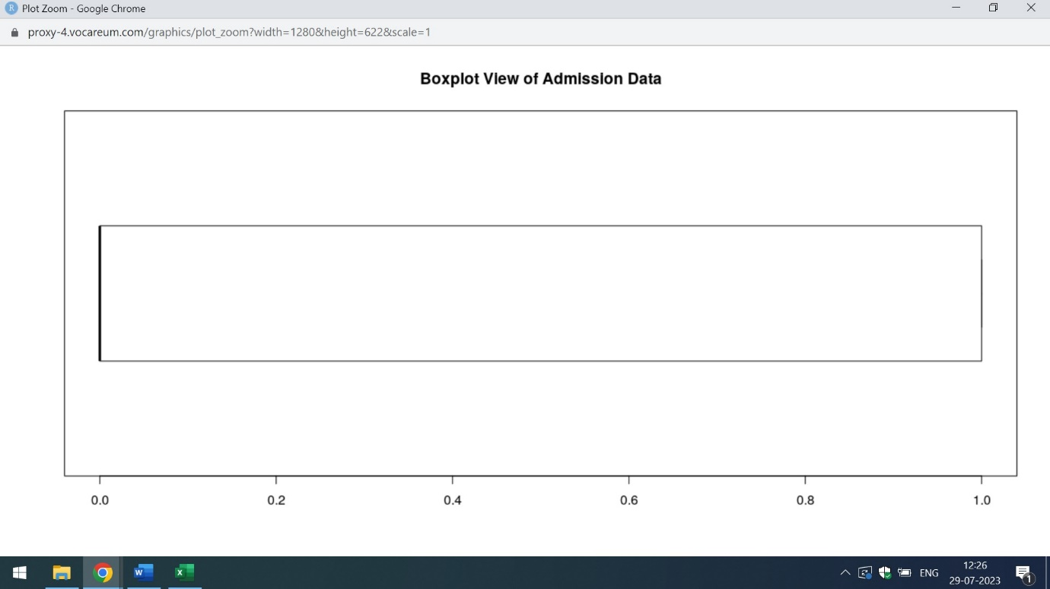

|  |
| --- |
| boxplot.stats(college_data$admit)$out  numeric(0)  > boxplot.stats(college_data$gre)$out  [1] 300 300 220 300  > boxplot.stats(college_data$gpa)$out  [1] 2.26  > boxplot.stats(college_data$ses)$out  numeric(0)  > boxplot.stats(college_data$Gender_Male)$out  numeric(0)  > boxplot.stats(college_data$Race)$out  numeric(0)  > boxplot.stats(college_data$rank)$out  numeric(0) |
|  |
| |  | | --- | | > | |

From,the above mention screenshot one can analyse that admission column has no outliers. However,the gre and gpa column has outlier values. The outlier values of the gre column are 300 and 220 and the gpa column is 2.26.

Below attached are the histogram of various columns

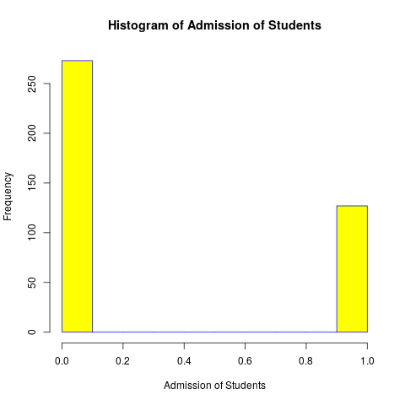

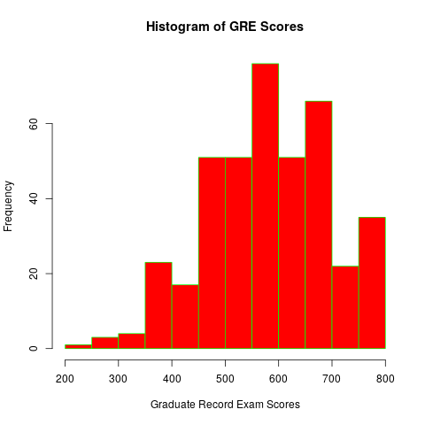

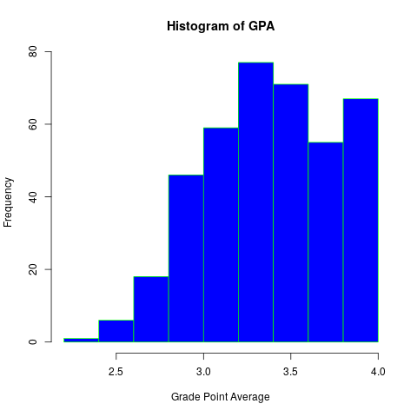

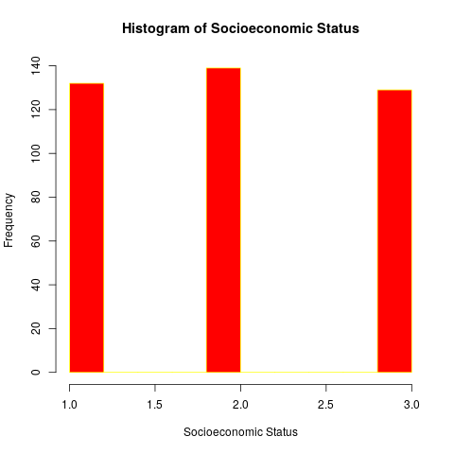

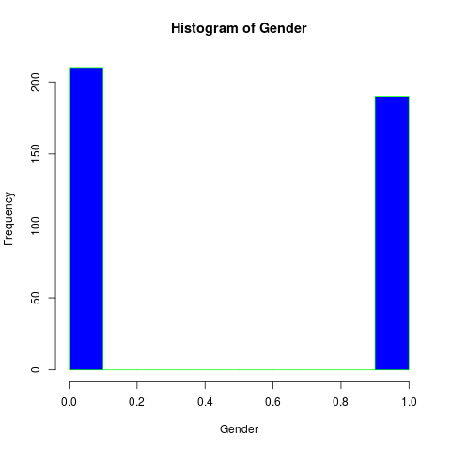

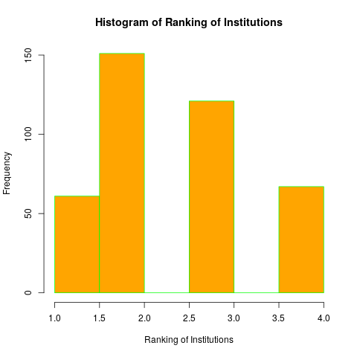

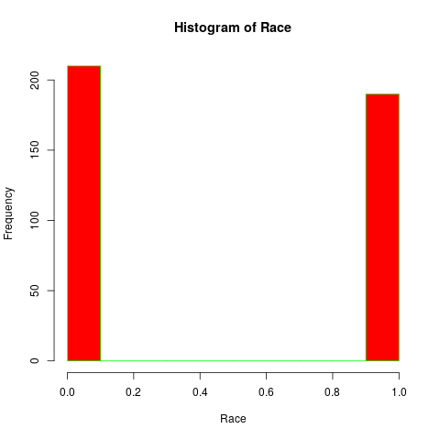

Q3) Find the structure of the data set and if required, transform the numeric data type to factor and vice-versa.

Ans) The below attached is the code in R which represents the structure of the dataset and conversion of all datatypes to factor and vice-versa

college_data<-read.csv("https://raw.githubusercontent.com/shivanipriya89/College/main/College.csv")

print(college_data)

View(college_data)

str(college_data)

# Converting Numeric Columns to Factor

college_data$rank<-sapply(college_data$rank,factor)

str(college_data$rank)

college_data$admit<-sapply(college_data$admit,factor)

str(college_data$admit)

college_data$ses<-sapply(college_data$ses,factor)

str(college_data$ses)

college_data$Gender_Male<-sapply(college_data$Gender_Male,factor)

str(college_data$Gender_Male)

college_data$Race<-sapply(college_data$Race,factor)

str(college_data$Race)

# Conversion of factors to Numeric

vec1<-as.numeric(college_data$Race)

vec2<-as.numeric(college_data$Rank)

vec3<-as.numeric(college_data$Gender_Male)

vec4<-as.numeric(college_data$ses)

vec5<-as.numeric(college_data$admit)

str(vec1)

str(vec2)

str(vec3)

str(vec4)

str(vec5)

str(college_data)

'data.frame': 400 obs. of 7 variables:

$ admit : int 0 1 1 1 0 1 1 0 1 0 ...

$ gre : int 380 660 800 640 520 760 560 400 540 700 ...

$ gpa : num 3.61 3.67 4 3.19 2.93 3 2.98 3.08 3.39 3.92 ...

$ ses : int 1 2 2 1 3 2 2 2 1 1 ...

$ Gender_Male: int 0 0 0 1 1 1 1 0 1 0 ...

$ Race : int 3 2 2 2 2 1 2 2 1 2 ...

$ rank : int 3 3 1 4 4 2 1 2 3 2 ...

The above mention screenshot represents the structure of college data set and datatypes of various columns. From the above mention screenshot,it is clear that except gpa rest of the columns has the integer datatypes

college_data$rank<-sapply(college_data$rank,factor)

> str(college_data$rank)

Factor w/ 4 levels "3","1","4","2": 1 1 2 3 3 4 2 4 1 4 ...

>

> college_data$admit<-sapply(college_data$admit,factor)

> str(college_data$admit)

Factor w/ 2 levels "0","1": 1 2 2 2 1 2 2 1 2 1 ...

>

> college_data$ses<-sapply(college_data$ses,factor)

> str(college_data$ses)

Factor w/ 3 levels "1","2","3": 1 2 2 1 3 2 2 2 1 1 ...

>

> college_data$Gender_Male<-sapply(college_data$Gender_Male,factor)

> str(college_data$Gender_Male)

Factor w/ 2 levels "0","1": 1 1 1 2 2 2 2 1 2 1 ...

>

> college_data$Race<-sapply(college_data$Race,factor)

> str(college_data$Race)

Factor w/ 3 levels "3","2","1": 1 2 2 2 2 3 2 2 3 2 ...

The above screenshot represents the factor conversion of all 7 columns.

str(vec1)

num [1:400] 1 2 2 2 2 3 2 2 3 2 ...

> str(vec1)

num [1:400] 1 2 2 2 2 3 2 2 3 2 ...

> str(vec2)

num(0)

> str(vec3)

num [1:400] 1 1 1 2 2 2 2 1 2 1 ...

> str(vec4)

num [1:400] 1 2 2 1 3 2 2 2 1 1 ...

> str(vec5)

num [1:400] 1 2 2 2 1 2 2 1 2 1 ...

The above mention screenshot represents that datatype of all 7 columns has been changed to numeric

Q4) Find whether the data is normally distributed or not. Use the plot to determine the same.

Ans) The below attached is the code in R which gives an overview of the Normal Distribution of data

college_data<-read.csv("https://raw.githubusercontent.com/shivanipriya89/College/main/College.csv")

print(college_data)

View(college_data)

str(college_data)

summary(college_data)

# Analysis of Normal Distribution

t1<-sd(college_data$admit)

t2<-sd(college_data$gre)

t3<-sd(college_data$gpa)

t4<-sd(college_data$ses)

t5<-sd(college_data$Gender_Male)

t6<-sd(college_data$Race)

t7<-sd(college_data$Rank)

print(t1)

print(t2)

print(t3) #0.38

print(t4) #0.81

print(t5) #0.5

print(t6) #0.82

print(t7) #Na

y1<- dnorm(college_data$admit, mean = 0.32, sd = 0.466)

plot(college_data$admit,y1)

y2<- dnorm(college_data$gre, mean = 588, sd = 116)

plot(college_data$gre,y2)

y3<- dnorm(college_data$gpa, mean = 3.4, sd = 0.38)

plot(college_data$gpa,y3)

y4<- dnorm(college_data$ses, mean = 0.2, sd = 0.81)

plot(college_data$ses,y4)

y5<- dnorm(college_data$Gender_Male, mean = 0.5, sd = 0.5)

plot(college_data$Gender_Male,y5)

y6<- dnorm(college_data$Race, mean = 2, sd = 0.82)

plot(college_data$Race,y6)

y7<- dnorm(college_data$rank, mean = 2.5, sd = 0)

plot(college_data$rank,y7)

Below attached are the screenshots.

|  |
| --- |
| t1<-sd(college_data$admit)  > t2<-sd(college_data$gre)  > t3<-sd(college_data$gpa)  > t4<-sd(college_data$ses)  > t5<-sd(college_data$Gender_Male)  > t6<-sd(college_data$Race)  > t7<-sd(college_data$Rank)  >  >  >  > print(t1)  [1] 0.4660867  > print(t2)  [1] 115.5165  > print(t3) #0.38  [1] 0.3805668  > print(t4) #0.81  [1] 0.8087515  > print(t5) #0.5  [1] 0.5  > print(t6) #0.82  [1] 0.8232789  > print(t7) #Na  [1] NA |
|  |
| |  | | --- | | > | |

The above mention screenshot represent the standard deviation of various columns

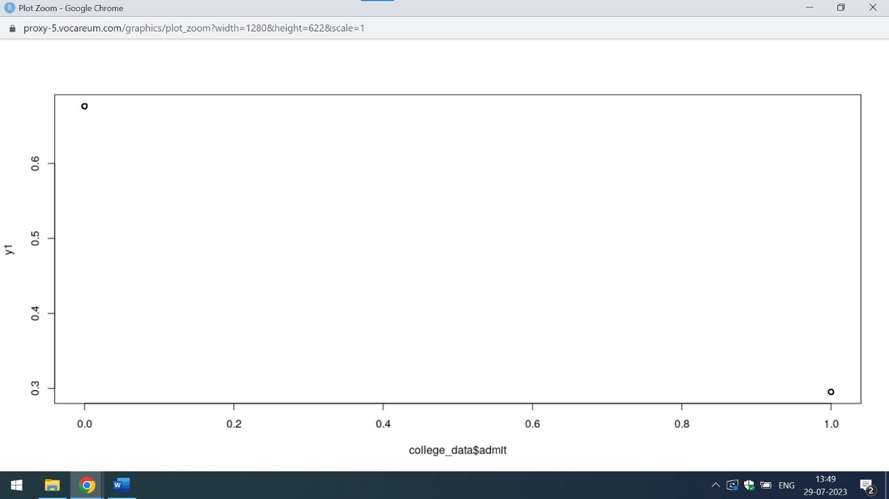

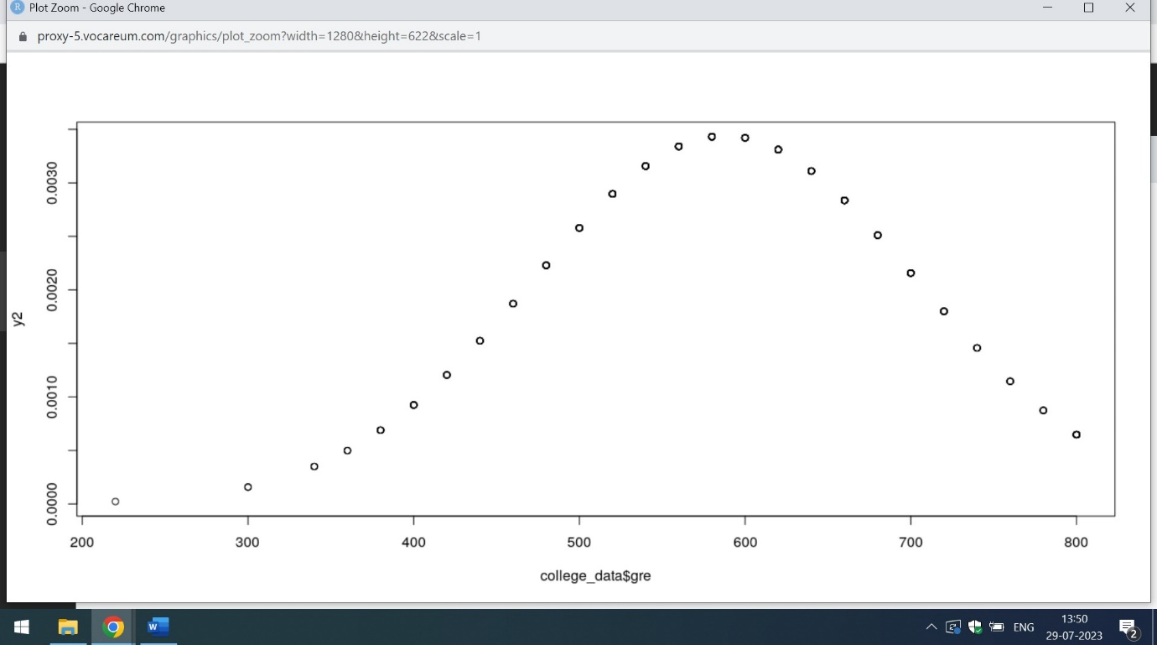

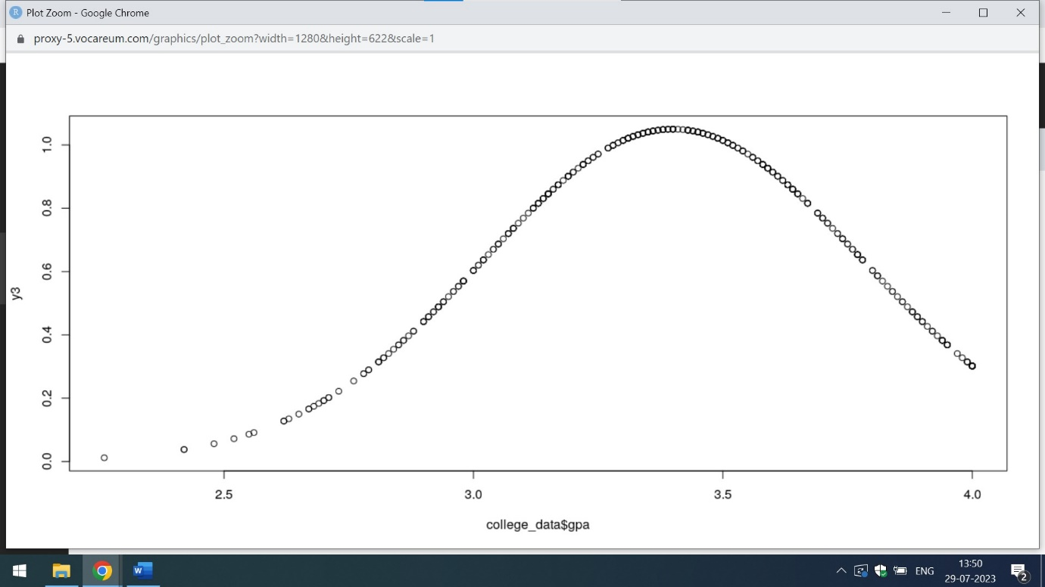

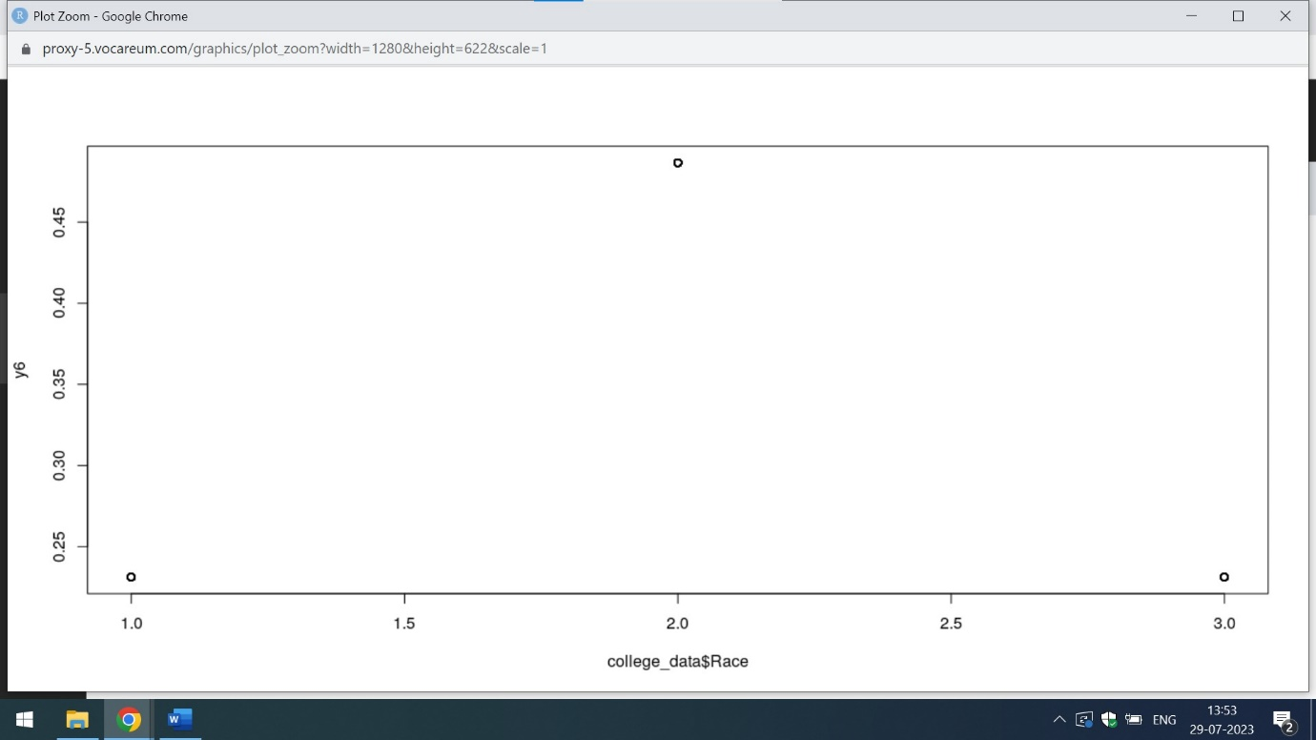

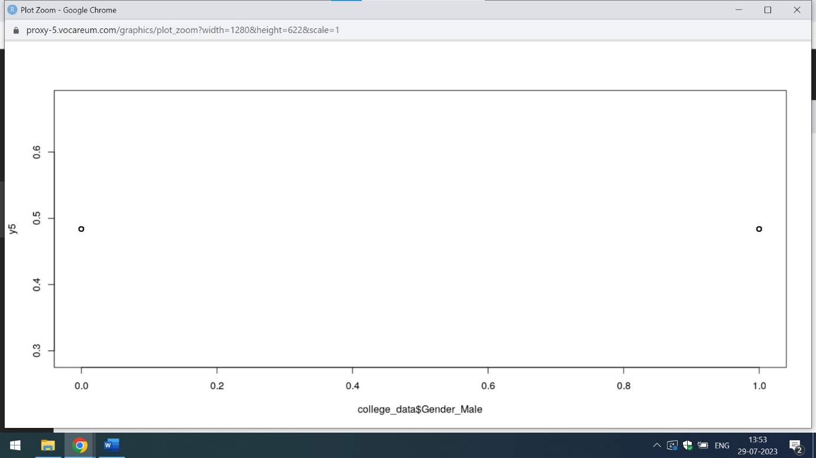

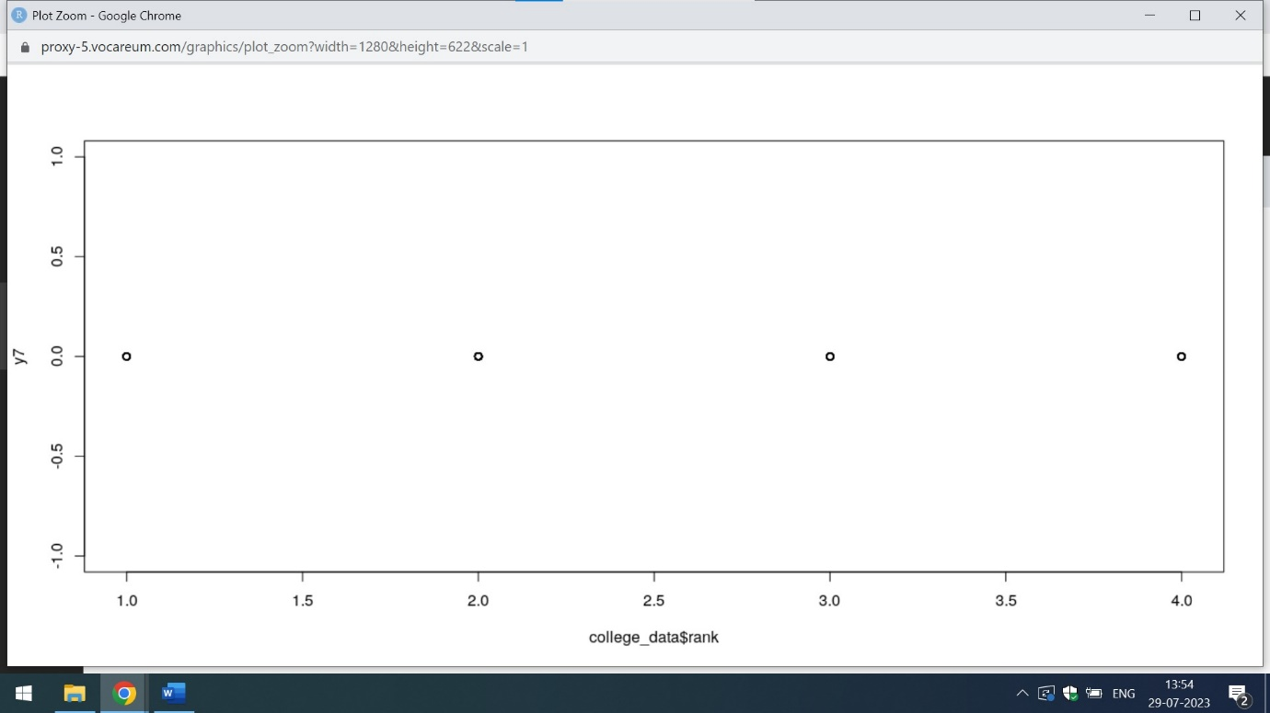

Normal distribution of data represents the bell shaped curve. From the above mention screenshot it is clear that only gre(Graduate Record Exam Scores) and gpa(Grade Point Average) column has normal distribution

Q5) Normalize the data if not normally distributed.

Ans) The below attached is the code in R which shows the normal distribution of data

college_data<-read.csv("https://raw.githubusercontent.com/shivanipriya89/College/main/College.csv")

print(college_data)

View(college_data)

summary(college_data)

log_scale = log(as.data.frame(college_data)) # Normalizing the data

print(log_scale)

scale_data<-as.data.frame(scale(college_data))

print(scale_data)

summary(college_data)

|  |
| --- |
| log_scale = log(as.data.frame(college_data)) # Normalizing the data  > print(log_scale)  admit gre gpa ses Gender_Male Race rank  1 -Inf 5.940171 1.2837078 0.0000000 -Inf 1.0986123 1.0986123  2 0 6.492240 1.3001917 0.6931472 -Inf 0.6931472 1.0986123  3 0 6.684612 1.3862944 0.6931472 -Inf 0.6931472 0.0000000  4 0 6.461468 1.1600209 0.0000000 0 0.6931472 1.3862944  5 -Inf 6.253829 1.0750024 1.0986123 0 0.6931472 1.3862944  6 0 6.633318 1.0986123 0.6931472 0 0.0000000 0.6931472  7 0 6.327937 1.0919233 0.6931472 0 0.6931472 0.0000000  8 -Inf 5.991465 1.1249296 0.6931472 -Inf 0.6931472 0.6931472  9 0 6.291569 1.2208299 0.0000000 0 0.0000000 1.0986123  10 -Inf 6.551080 1.3660917 0.0000000 -Inf 0.6931472 0.6931472  11 -Inf 6.684612 1.3862944 0.0000000 0 0.0000000 1.3862944  12 -Inf 6.086775 1.1693814 1.0986123 -Inf 0.6931472 0.0000000  13 0 6.633318 1.3862944 1.0986123 0 0.6931472 0.0000000  14 -Inf 6.551080 1.1249296 0.6931472 -Inf 0.6931472 0.6931472  15 0 6.551080 1.3862944 0.6931472 0 0.0000000 0.0000000  16 -Inf 6.173786 1.2354715 1.0986123 -Inf 0.0000000 1.0986123  17 -Inf 6.659294 1.3532545 0.6931472 -Inf 1.0986123 1.3862944  18 -Inf 5.886104 0.9400073 1.0986123 0 1.0986123 1.0986123  19 -Inf 6.684612 1.3217558 0.0000000 0 1.0986123 0.6931472  20 0 6.291569 1.3376292 0.0000000 -Inf 1.0986123 0.0000000  21 -Inf 6.214608 1.1537316 1.0986123 -Inf 0.6931472 1.0986123  22 0 6.492240 1.2892326 0.0000000 -Inf 0.0000000 0.6931472  23 -Inf 6.396930 1.0367369 0.0000000 -Inf 1.0986123 1.3862944  24 -Inf 6.522093 1.1600209 0.0000000 -Inf 0.0000000 1.3862944  25 0 6.633318 1.2089603 0.6931472 -Inf 0.6931472 0.6931472  26 0 6.684612 1.2974631 0.6931472 0 0.0000000 0.0000000  27 0 6.429719 1.2837078 0.6931472 -Inf 0.0000000 0.0000000  28 0 6.253829 1.3190856 0.6931472 -Inf 1.0986123 1.3862944  29 0 6.659294 1.1693814 0.0000000 -Inf 0.0000000 0.6931472  30 -Inf 6.253829 1.1908876 0.0000000 -Inf 0.0000000 0.0000000  31 -Inf 6.291569 1.3297240 0.0000000 0 0.0000000 1.3862944  32 -Inf 6.633318 1.2089603 0.6931472 0 0.0000000 1.0986123  33 -Inf 6.396930 1.2237754 1.0986123 -Inf 0.0000000 1.0986123  34 0 6.684612 1.3862944 1.0986123 -Inf 0.0000000 1.0986123  35 -Inf 5.886104 1.1442228 0.0000000 0 0.6931472 0.0000000  36 -Inf 5.991465 1.1151416 1.0986123 -Inf 0.6931472 0.6931472  37 -Inf 6.363028 1.1786550 0.0000000 -Inf 0.6931472 0.0000000  38 -Inf 6.253829 1.0647107 0.6931472 -Inf 0.6931472 1.0986123  39 0 6.214608 1.1410330 0.6931472 -Inf 0.6931472 0.6931472  40 0 6.253829 0.9858168 0.6931472 -Inf 0.0000000 1.0986123  41 -Inf 6.327937 0.8837675 0.0000000 0 1.0986123 0.6931472  42 0 6.363028 1.1999648 0.0000000 -Inf 0.0000000 0.6931472  43 0 6.396930 1.1474025 0.6931472 0 0.0000000 0.6931472  44 -Inf 6.214608 1.1969482 0.6931472 -Inf 0.6931472 1.0986123  45 -Inf 6.551080 1.0784096 0.0000000 -Inf 1.0986123 0.6931472  46 0 6.131226 1.2383742 0.6931472 0 1.0986123 1.0986123  47 0 6.363028 1.2412686 1.0986123 0 0.0000000 0.6931472  48 -Inf 6.214608 1.0885620 1.0986123 -Inf 0.6931472 1.3862944  49 -Inf 6.086775 0.9082586 1.0986123 -Inf 1.0986123 1.3862944  50 -Inf 5.991465 1.2089603 1.0986123 -Inf 0.0000000 1.0986123  51 -Inf 6.461468 1.3506672 0.6931472 0 1.0986123 1.0986123  52 -Inf 6.086775 1.1410330 0.6931472 -Inf 0.6931472 1.3862944  53 -Inf 6.606650 1.2149127 0.6931472 0 1.0986123 1.3862944  54 0 6.522093 1.1847900 0.6931472 -Inf 0.6931472 0.6931472  55 -Inf 6.492240 1.2059708 0.0000000 -Inf 0.0000000 1.0986123  56 0 6.606650 1.3862944 0.0000000 0 0.6931472 1.0986123  57 -Inf 6.327937 1.1600209 1.0986123 0 0.0000000 1.0986123  58 -Inf 5.940171 1.0784096 1.0986123 -Inf 0.6931472 1.0986123  59 -Inf 5.991465 1.2947272 1.0986123 0 0.6931472 0.6931472  60 -Inf 6.396930 1.0367369 1.0986123 0 0.0000000 1.3862944  61 0 6.429719 1.1568812 0.6931472 0 0.0000000 0.6931472  62 -Inf 6.327937 1.1999648 0.0000000 -Inf 1.0986123 1.3862944  63 -Inf 6.461468 1.3001917 0.0000000 0 0.6931472 1.0986123  64 0 6.522093 1.3480731 0.0000000 0 1.0986123 1.0986123  65 -Inf 6.363028 1.3862944 0.6931472 0 1.0986123 1.0986123  66 -Inf 6.396930 1.2781522 0.0000000 -Inf 0.0000000 0.6931472  67 -Inf 6.606650 1.2864740 1.0986123 0 0.6931472 1.3862944  68 -Inf 6.429719 1.1939225 0.6931472 0 1.0986123 0.0000000  69 -Inf 6.363028 1.3056265 1.0986123 -Inf 1.0986123 0.0000000  70 -Inf 6.684612 1.3164082 0.0000000 0 0.0000000 0.0000000  71 -Inf 6.461468 1.3862944 0.0000000 0 0.0000000 1.0986123  72 -Inf 5.703782 1.0715836 0.0000000 0 0.0000000 1.3862944  73 -Inf 6.173786 1.2208299 0.6931472 -Inf 0.6931472 1.3862944  74 -Inf 6.363028 1.3862944 1.0986123 -Inf 1.0986123 0.6931472  75 -Inf 6.579251 1.2383742 0.6931472 0 0.6931472 1.3862944  76 -Inf 6.579251 1.3862944 0.6931472 -Inf 1.0986123 1.0986123  77 -Inf 6.327937 1.2119410 0.0000000 0 0.6931472 1.0986123  78 0 6.684612 1.3862944 1.0986123 -Inf 1.0986123 1.0986123  79 -Inf 6.291569 1.1378330 1.0986123 0 0.6931472 0.0000000  80 0 6.429719 1.3862944 0.6931472 -Inf 0.6931472 0.0000000  81 -Inf 6.551080 1.0647107 0.6931472 -Inf 0.6931472 1.3862944  82 -Inf 6.429719 1.1216776 1.0986123 0 0.6931472 0.6931472  83 -Inf 6.214608 0.9969486 0.6931472 -Inf 1.0986123 0.6931472  84 -Inf 5.940171 1.0681531 1.0986123 0 0.6931472 1.3862944  85 0 6.214608 1.2809338 0.0000000 0 0.0000000 1.0986123  86 -Inf 6.253829 1.0919233 0.6931472 -Inf 0.6931472 0.6931472  87 -Inf 6.396930 1.1999648 0.0000000 -Inf 1.0986123 0.6931472  88 -Inf 6.396930 1.2470323 0.0000000 -Inf 0.0000000 0.6931472  89 -Inf 6.551080 1.1878434 1.0986123 -Inf 1.0986123 0.0000000  90 0 6.492240 1.3862944 0.0000000 0 0.0000000 0.6931472  91 -Inf 6.551080 1.3428648 0.6931472 -Inf 0.6931472 0.6931472  92 0 6.579251 1.2919837 0.6931472 -Inf 0.6931472 0.0000000  93 -Inf 6.684612 1.3609766 1.0986123 0 0.0000000 0.6931472  94 -Inf 6.363028 1.0750024 1.0986123 0 0.0000000 0.6931472  95 0 6.492240 1.2354715 0.6931472 -Inf 1.0986123 0.6931472  96 -Inf 6.492240 1.2029723 0.6931472 0 1.0986123 0.6931472  97 -Inf 6.461468 1.2584610 0.6931472 0 1.0986123 1.3862944  98 -Inf 6.173786 1.2725656 1.0986123 0 0.6931472 0.6931472  99 -Inf 6.551080 1.0577903 0.6931472 0 1.0986123 0.6931472  100 -Inf 5.991465 1.1969482 1.0986123 0 0.6931472 1.0986123  101 -Inf 5.828946 1.1474025 0.6931472 -Inf 0.0000000 1.0986123  102 -Inf 6.363028 1.2725656 0.0000000 0 0.6931472 1.0986123  103 -Inf 5.940171 1.2029723 1.0986123 -Inf 1.0986123 1.3862944  104 -Inf 6.291569 1.3711807 1.0986123 -Inf 0.0000000 1.0986123  105 0 6.492240 1.3737156 0.6931472 0 0.0000000 0.6931472  106 0 6.606650 1.0885620 0.0000000 0 0.0000000 0.6931472  107 0 6.551080 1.2697605 0.0000000 0 0.6931472 0.0000000  108 -Inf 6.173786 1.1410330 0.6931472 -Inf 0.0000000 0.6931472  109 -Inf 5.991465 1.0750024 0.0000000 0 1.0986123 1.0986123  110 -Inf 6.173786 1.2383742 1.0986123 -Inf 0.0000000 0.6931472  111 -Inf 6.522093 1.1249296 1.0986123 -Inf 1.0986123 1.3862944  112 -Inf 6.040255 1.2267123 0.6931472 0 1.0986123 1.3862944  113 -Inf 5.886104 1.0986123 0.0000000 -Inf 0.0000000 1.0986123  114 -Inf 6.396930 1.1693814 1.0986123 0 0.6931472 0.0000000  115 -Inf 6.579251 1.3454724 0.0000000 0 0.6931472 1.0986123  116 -Inf 6.429719 1.3837912 0.6931472 0 0.6931472 1.0986123  117 0 6.086775 1.2383742 0.0000000 0 1.0986123 0.6931472  118 -Inf 6.551080 1.3137237 0.6931472 0 0.6931472 0.6931472  119 0 6.684612 1.3083328 0.0000000 -Inf 0.6931472 0.0000000  120 -Inf 5.828946 1.0715836 1.0986123 0 0.6931472 1.0986123  121 0 6.253829 1.3190856 0.6931472 -Inf 0.6931472 0.6931472  122 0 6.173786 0.9820785 0.0000000 -Inf 0.0000000 0.6931472  123 -Inf 6.253829 1.0473190 1.0986123 -Inf 0.0000000 1.0986123  124 -Inf 6.214608 1.0919233 1.0986123 -Inf 0.6931472 1.0986123  125 -Inf 6.579251 1.3558352 0.6931472 -Inf 1.0986123 1.0986123  126 -Inf 6.291569 1.2178757 1.0986123 -Inf 1.0986123 1.3862944  127 0 6.396930 1.2641267 1.0986123 -Inf 1.0986123 0.0000000  128 -Inf 6.606650 1.3190856 0.0000000 -Inf 1.0986123 1.3862944  129 -Inf 6.291569 1.1600209 0.0000000 0 1.0986123 0.6931472  130 -Inf 6.131226 1.1474025 1.0986123 -Inf 0.6931472 1.3862944  131 0 6.429719 1.1537316 0.0000000 -Inf 1.0986123 0.6931472  132 -Inf 6.461468 1.0260416 1.0986123 0 0.0000000 0.6931472  133 -Inf 6.363028 1.2237754 1.0986123 -Inf 0.0000000 0.6931472  134 -Inf 6.214608 1.1249296 0.6931472 0 0.6931472 1.0986123  135 -Inf 6.327937 1.0818052 1.0986123 0 0.0000000 0.6931472  136 -Inf 6.214608 1.2725656 0.6931472 0 1.0986123 1.0986123  137 -Inf 6.327937 1.2029723 1.0986123 0 0.6931472 1.3862944  138 -Inf 6.551080 1.3862944 1.0986123 0 0.0000000 1.0986123  139 -Inf 6.429719 1.2237754 1.0986123 -Inf 0.0000000 0.6931472  140 0 6.396930 1.2753628 1.0986123 -Inf 1.0986123 0.0000000  141 -Inf 6.461468 1.3686394 0.6931472 0 0.6931472 0.6931472  142 0 6.551080 1.2584610 0.6931472 -Inf 0.0000000 1.3862944  [ reached 'max' / getOption("max.print") -- omitted 258 rows ] |
|  |
| |  | | --- | | > | |

scale_data<-as.data.frame(scale(college_data))

> print(scale_data)

admit gre gpa ses Gender_Male

1 -0.6812037 -1.79801097 0.578347918 -1.227200236 -0.95

2 1.4643197 0.62588442 0.736007505 0.009273553 -0.95

3 1.4643197 1.83783211 1.603135233 0.009273553 -0.95

4 1.4643197 0.45274903 -0.525269190 -1.227200236 1.05

5 -0.6812037 -0.58606328 -1.208460734 1.245747343 1.05

6 1.4643197 1.49156134 -1.024524549 0.009273553 1.05

7 1.4643197 -0.23979251 -1.077077744 0.009273553 1.05

8 -0.6812037 -1.62487559 -0.814311766 0.009273553 -0.95

9 1.4643197 -0.41292789 0.000262766 -1.227200236 1.05

10 -0.6812037 0.97215519 1.392922450 -1.227200236 -0.95

11 -0.6812037 1.83783211 1.603135233 -1.227200236 1.05

12 -0.6812037 -1.27860482 -0.446439397 1.245747343 -0.95

13 1.4643197 1.49156134 1.603135233 1.245747343 1.05

14 -0.6812037 0.97215519 -0.814311766 0.009273553 -0.95

15 1.4643197 0.97215519 1.603135233 0.009273553 1.05

16 -0.6812037 -0.93233405 0.131645755 1.245747343 -0.95

17 -0.6812037 1.66469673 1.261539461 0.009273553 -0.95

18 -0.6812037 -1.97114636 -2.180694853 1.245747343 1.05

19 -0.6812037 1.83783211 0.946220287 -1.227200236 1.05

20 1.4643197 -0.41292789 1.103879874 -1.227200236 -0.95

21 -0.6812037 -0.75919866 -0.577822386 1.245747343 -0.95

22 1.4643197 0.62588442 0.630901114 -1.227200236 -0.95

23 -0.6812037 0.10647826 -1.497503309 -1.227200236 -0.95

24 -0.6812037 0.79901980 -0.525269190 -1.227200236 -0.95

25 1.4643197 1.49156134 -0.104843625 0.009273553 -0.95

26 1.4643197 1.83783211 0.709730907 0.009273553 1.05

27 1.4643197 0.27961365 0.578347918 0.009273553 -0.95

28 1.4643197 -0.58606328 0.919943690 0.009273553 -0.95

29 1.4643197 1.66469673 -0.446439397 -1.227200236 -0.95

30 -0.6812037 -0.58606328 -0.262503212 -1.227200236 -0.95

31 -0.6812037 -0.41292789 1.025050081 -1.227200236 1.05

32 -0.6812037 1.49156134 -0.104843625 0.009273553 1.05

33 -0.6812037 0.10647826 0.026539364 1.245747343 -0.95

34 1.4643197 1.83783211 1.603135233 1.245747343 -0.95

35 -0.6812037 -1.97114636 -0.656652179 -1.227200236 1.05

36 -0.6812037 -1.62487559 -0.893141560 1.245747343 -0.95

37 -0.6812037 -0.06665712 -0.367609603 -1.227200236 -0.95

38 -0.6812037 -0.58606328 -1.287290527 0.009273553 -0.95

39 1.4643197 -0.75919866 -0.682928777 0.009273553 -0.95

40 1.4643197 -0.58606328 -1.865375679 0.009273553 -0.95

41 -0.6812037 -0.23979251 -2.548567222 -1.227200236 1.05

42 1.4643197 -0.06665712 -0.183673419 -1.227200236 -0.95

43 1.4643197 0.10647826 -0.630375582 0.009273553 1.05

44 -0.6812037 -0.75919866 -0.209950017 0.009273553 -0.95

45 -0.6812037 0.97215519 -1.182184136 -1.227200236 -0.95

46 1.4643197 -1.10546943 0.157922353 0.009273553 1.05

47 1.4643197 -0.06665712 0.184198951 1.245747343 1.05

48 -0.6812037 -0.75919866 -1.103354342 1.245747343 -0.95

49 -0.6812037 -1.27860482 -2.390907635 1.245747343 -0.95

50 -0.6812037 -1.62487559 -0.104843625 1.245747343 -0.95

51 -0.6812037 0.45274903 1.235262863 0.009273553 1.05

52 -0.6812037 -1.27860482 -0.682928777 0.009273553 -0.95

53 -0.6812037 1.31842596 -0.052290430 0.009273553 1.05

54 1.4643197 0.79901980 -0.315056408 0.009273553 -0.95

55 -0.6812037 0.62588442 -0.131120223 -1.227200236 -0.95

56 1.4643197 1.31842596 1.603135233 -1.227200236 1.05

57 -0.6812037 -0.23979251 -0.525269190 1.245747343 1.05

58 -0.6812037 -1.79801097 -1.182184136 1.245747343 -0.95

59 -0.6812037 -1.62487559 0.683454309 1.245747343 1.05

60 -0.6812037 0.10647826 -1.497503309 1.245747343 1.05

61 1.4643197 0.27961365 -0.551545788 0.009273553 1.05

62 -0.6812037 -0.23979251 -0.183673419 -1.227200236 -0.95

63 -0.6812037 0.45274903 0.736007505 -1.227200236 1.05

64 1.4643197 0.79901980 1.208986265 -1.227200236 1.05

65 -0.6812037 -0.06665712 1.603135233 0.009273553 1.05

66 -0.6812037 0.10647826 0.525794722 -1.227200236 -0.95

67 -0.6812037 1.31842596 0.604624516 1.245747343 1.05

68 -0.6812037 0.27961365 -0.236226614 0.009273553 1.05

69 -0.6812037 -0.06665712 0.788560700 1.245747343 -0.95

70 -0.6812037 1.83783211 0.893667092 -1.227200236 1.05

71 -0.6812037 0.45274903 1.603135233 -1.227200236 1.05

72 -0.6812037 -2.49055251 -1.234737331 -1.227200236 1.05

73 -0.6812037 -0.93233405 0.000262766 0.009273553 -0.95

74 -0.6812037 -0.06665712 1.603135233 1.245747343 -0.95

75 -0.6812037 1.14529057 0.157922353 0.009273553 1.05

76 -0.6812037 1.14529057 1.603135233 0.009273553 -0.95

77 -0.6812037 -0.23979251 -0.078567027 -1.227200236 1.05

78 1.4643197 1.83783211 1.603135233 1.245747343 -0.95

79 -0.6812037 -0.41292789 -0.709205375 1.245747343 1.05

80 1.4643197 0.27961365 1.603135233 0.009273553 -0.95

81 -0.6812037 0.97215519 -1.287290527 0.009273553 -0.95

82 -0.6812037 0.27961365 -0.840588364 1.245747343 1.05

83 -0.6812037 -0.75919866 -1.786545885 0.009273553 -0.95

84 -0.6812037 -1.79801097 -1.261013929 1.245747343 1.05

85 1.4643197 -0.75919866 0.552071320 -1.227200236 1.05

86 -0.6812037 -0.58606328 -1.077077744 0.009273553 -0.95

87 -0.6812037 0.10647826 -0.183673419 -1.227200236 -0.95

88 -0.6812037 0.10647826 0.236752146 -1.227200236 -0.95

89 -0.6812037 0.97215519 -0.288779810 1.245747343 -0.95

90 1.4643197 0.62588442 1.603135233 -1.227200236 1.05

91 -0.6812037 0.97215519 1.156433070 0.009273553 -0.95

92 1.4643197 1.14529057 0.657177711 0.009273553 -0.95

93 -0.6812037 1.83783211 1.340369255 1.245747343 1.05

94 -0.6812037 -0.06665712 -1.208460734 1.245747343 1.05

95 1.4643197 0.62588442 0.131645755 0.009273553 -0.95

96 -0.6812037 0.62588442 -0.157396821 0.009273553 1.05

97 -0.6812037 0.45274903 0.341858538 0.009273553 1.05

98 -0.6812037 -0.93233405 0.473241527 1.245747343 1.05

99 -0.6812037 0.97215519 -1.339843723 0.009273553 1.05

100 -0.6812037 -1.62487559 -0.209950017 1.245747343 1.05

101 -0.6812037 -2.14428174 -0.630375582 0.009273553 -0.95

102 -0.6812037 -0.06665712 0.473241527 -1.227200236 1.05

103 -0.6812037 -1.79801097 -0.157396821 1.245747343 -0.95

104 -0.6812037 -0.41292789 1.445475646 1.245747343 -0.95

105 1.4643197 0.62588442 1.471752244 0.009273553 1.05

106 1.4643197 1.31842596 -1.103354342 -1.227200236 1.05

107 1.4643197 0.97215519 0.446964929 -1.227200236 1.05

108 -0.6812037 -0.93233405 -0.682928777 0.009273553 -0.95

109 -0.6812037 -1.62487559 -1.208460734 -1.227200236 1.05

110 -0.6812037 -0.93233405 0.157922353 1.245747343 -0.95

111 -0.6812037 0.79901980 -0.814311766 1.245747343 -0.95

112 -0.6812037 -1.45174020 0.052815962 0.009273553 1.05

113 -0.6812037 -1.97114636 -1.024524549 -1.227200236 -0.95

114 -0.6812037 0.10647826 -0.446439397 1.245747343 1.05

115 -0.6812037 1.14529057 1.182709668 -1.227200236 1.05

116 -0.6812037 0.27961365 1.576858635 0.009273553 1.05

117 1.4643197 -1.27860482 0.157922353 -1.227200236 1.05

118 -0.6812037 0.97215519 0.867390494 0.009273553 1.05

119 1.4643197 1.83783211 0.814837298 -1.227200236 -0.95

120 -0.6812037 -2.14428174 -1.234737331 1.245747343 1.05

121 1.4643197 -0.58606328 0.919943690 0.009273553 -0.95

122 1.4643197 -0.93233405 -1.891652277 -1.227200236 -0.95

123 -0.6812037 -0.58606328 -1.418673516 1.245747343 -0.95

124 -0.6812037 -0.75919866 -1.077077744 1.245747343 -0.95

125 -0.6812037 1.14529057 1.287816059 0.009273553 -0.95

126 -0.6812037 -0.41292789 -0.026013832 1.245747343 -0.95

127 1.4643197 0.10647826 0.394411733 1.245747343 -0.95

128 -0.6812037 1.31842596 0.919943690 -1.227200236 -0.95

129 -0.6812037 -0.41292789 -0.525269190 -1.227200236 1.05

130 -0.6812037 -1.10546943 -0.630375582 1.245747343 -0.95

131 1.4643197 0.27961365 -0.577822386 -1.227200236 -0.95

132 -0.6812037 0.45274903 -1.576333103 1.245747343 1.05

133 -0.6812037 -0.06665712 0.026539364 1.245747343 -0.95

134 -0.6812037 -0.75919866 -0.814311766 0.009273553 1.05

135 -0.6812037 -0.23979251 -1.155907538 1.245747343 1.05

136 -0.6812037 -0.75919866 0.473241527 0.009273553 1.05

137 -0.6812037 -0.23979251 -0.157396821 1.245747343 1.05

138 -0.6812037 0.97215519 1.603135233 1.245747343 1.05

139 -0.6812037 0.27961365 0.026539364 1.245747343 -0.95

140 1.4643197 0.10647826 0.499518124 1.245747343 -0.95

141 -0.6812037 0.45274903 1.419199048 0.009273553 1.05

142 1.4643197 0.97215519 0.341858538 0.009273553 -0.95

Race rank

1 1.26020471 0.5452850

2 0.04554957 0.5452850

3 0.04554957 -1.5723268

4 0.04554957 1.6040909

5 0.04554957 1.6040909

6 -1.16910557 -0.5135209

7 0.04554957 -1.5723268

8 0.04554957 -0.5135209

9 -1.16910557 0.5452850

10 0.04554957 -0.5135209

11 -1.16910557 1.6040909

12 0.04554957 -1.5723268

13 0.04554957 -1.5723268

14 0.04554957 -0.5135209

15 -1.16910557 -1.5723268

16 -1.16910557 0.5452850

17 1.26020471 1.6040909

18 1.26020471 0.5452850

19 1.26020471 -0.5135209

20 1.26020471 -1.5723268

21 0.04554957 0.5452850

22 -1.16910557 -0.5135209

23 1.26020471 1.6040909

24 -1.16910557 1.6040909

25 0.04554957 -0.5135209

26 -1.16910557 -1.5723268

27 -1.16910557 -1.5723268

28 1.26020471 1.6040909

29 -1.16910557 -0.5135209

30 -1.16910557 -1.5723268

31 -1.16910557 1.6040909

32 -1.16910557 0.5452850

33 -1.16910557 0.5452850

34 -1.16910557 0.5452850

35 0.04554957 -1.5723268

36 0.04554957 -0.5135209

37 0.04554957 -1.5723268

38 0.04554957 0.5452850

39 0.04554957 -0.5135209

40 -1.16910557 0.5452850

41 1.26020471 -0.5135209

42 -1.16910557 -0.5135209

43 -1.16910557 -0.5135209

44 0.04554957 0.5452850

45 1.26020471 -0.5135209

46 1.26020471 0.5452850

47 -1.16910557 -0.5135209

48 0.04554957 1.6040909

49 1.26020471 1.6040909

50 -1.16910557 0.5452850

51 1.26020471 0.5452850

52 0.04554957 1.6040909

53 1.26020471 1.6040909

54 0.04554957 -0.5135209

55 -1.16910557 0.5452850

56 0.04554957 0.5452850

57 -1.16910557 0.5452850

58 0.04554957 0.5452850

59 0.04554957 -0.5135209

60 -1.16910557 1.6040909

61 -1.16910557 -0.5135209

62 1.26020471 1.6040909

63 0.04554957 0.5452850

64 1.26020471 0.5452850

65 1.26020471 0.5452850

66 -1.16910557 -0.5135209

67 0.04554957 1.6040909

68 1.26020471 -1.5723268

69 1.26020471 -1.5723268

70 -1.16910557 -1.5723268

71 -1.16910557 0.5452850

72 -1.16910557 1.6040909

73 0.04554957 1.6040909

74 1.26020471 -0.5135209

75 0.04554957 1.6040909

76 1.26020471 0.5452850

77 0.04554957 0.5452850

78 1.26020471 0.5452850

79 0.04554957 -1.5723268

80 0.04554957 -1.5723268

81 0.04554957 1.6040909

82 0.04554957 -0.5135209

83 1.26020471 -0.5135209

84 0.04554957 1.6040909

85 -1.16910557 0.5452850

86 0.04554957 -0.5135209

87 1.26020471 -0.5135209

88 -1.16910557 -0.5135209

89 1.26020471 -1.5723268

90 -1.16910557 -0.5135209

91 0.04554957 -0.5135209

92 0.04554957 -1.5723268

93 -1.16910557 -0.5135209

94 -1.16910557 -0.5135209

95 1.26020471 -0.5135209

96 1.26020471 -0.5135209

97 1.26020471 1.6040909

98 0.04554957 -0.5135209

99 1.26020471 -0.5135209

100 0.04554957 0.5452850

101 -1.16910557 0.5452850

102 0.04554957 0.5452850

103 1.26020471 1.6040909

104 -1.16910557 0.5452850

105 -1.16910557 -0.5135209

106 -1.16910557 -0.5135209

107 0.04554957 -1.5723268

108 -1.16910557 -0.5135209

109 1.26020471 0.5452850

110 -1.16910557 -0.5135209

111 1.26020471 1.6040909

112 1.26020471 1.6040909

113 -1.16910557 0.5452850

114 0.04554957 -1.5723268

115 0.04554957 0.5452850

116 0.04554957 0.5452850

117 1.26020471 -0.5135209

118 0.04554957 -0.5135209

119 0.04554957 -1.5723268

120 0.04554957 0.5452850

121 0.04554957 -0.5135209

122 -1.16910557 -0.5135209

123 -1.16910557 0.5452850

124 0.04554957 0.5452850

125 1.26020471 0.5452850

126 1.26020471 1.6040909

127 1.26020471 -1.5723268

128 1.26020471 1.6040909

129 1.26020471 -0.5135209

130 0.04554957 1.6040909

131 1.26020471 -0.5135209

132 -1.16910557 -0.5135209

133 -1.16910557 -0.5135209

134 0.04554957 0.5452850

135 -1.16910557 -0.5135209

136 1.26020471 0.5452850

137 0.04554957 1.6040909

138 -1.16910557 0.5452850

139 -1.16910557 -0.5135209

140 1.26020471 -1.5723268

141 0.04554957 -0.5135209

142 -1.16910557 1.6040909

[ reached 'max' / getOption("max.print") -- omitted 258 rows ]

The above mention screenshot represent the normalize view of data. Data’s are normalized via log and scale functions. The output of scale and log values are attached in the above mentioned screenshots

Q6) Use variable reduction techniques to identify significant variables.

Ans) Principal Component Analysis(PCA) is an important variable reduction techniques to identify the significant variables in R

Below attached is the code in R

college_data<-read.csv("https://raw.githubusercontent.com/shivanipriya89/College/main/College.csv")

print(college_data)

View(college_data)

data_normalized <- scale(college_data)

head(data_normalized)

corr_matrix <- cor(data_normalized)

data.pca <- princomp(corr_matrix)

summary(data.pca)

fviz_eig(data.pca, addlabels = TRUE)

fviz_pca_var(data.pca, col.var = "black")

|  |
| --- |
| corr_matrix <- cor(data_normalized)  > data.pca <- princomp(corr_matrix)  > summary(data.pca)  Importance of components:  Comp.1 Comp.2 Comp.3 Comp.4 Comp.5  Standard deviation 0.5705470 0.4111876 0.3893538 0.3627437 0.3141902  Proportion of Variance 0.3503618 0.1819759 0.1631634 0.1416229 0.1062476  Cumulative Proportion 0.3503618 0.5323377 0.6955011 0.8371240 0.9433716  Comp.6 Comp.7  Standard deviation 0.22937709 2.528936e-09  Proportion of Variance 0.05662836 6.883506e-18  Cumulative Proportion 1.00000000 1.000000e+00 |
|  |
| |  | | --- | | > | |

The above mention screenshot represents the standard deviation,proportion of variance and Cumulative proportion of various components

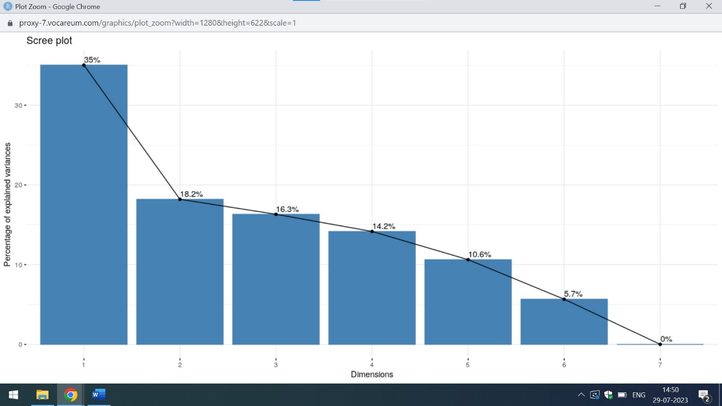

The above attached is the screeplot which explains the percentage of explained variances over dimensions. The first two components ie component 1 and component 2 holds the 53% of overall information of data. Hence the two most important variables of the dataset are admit and gre

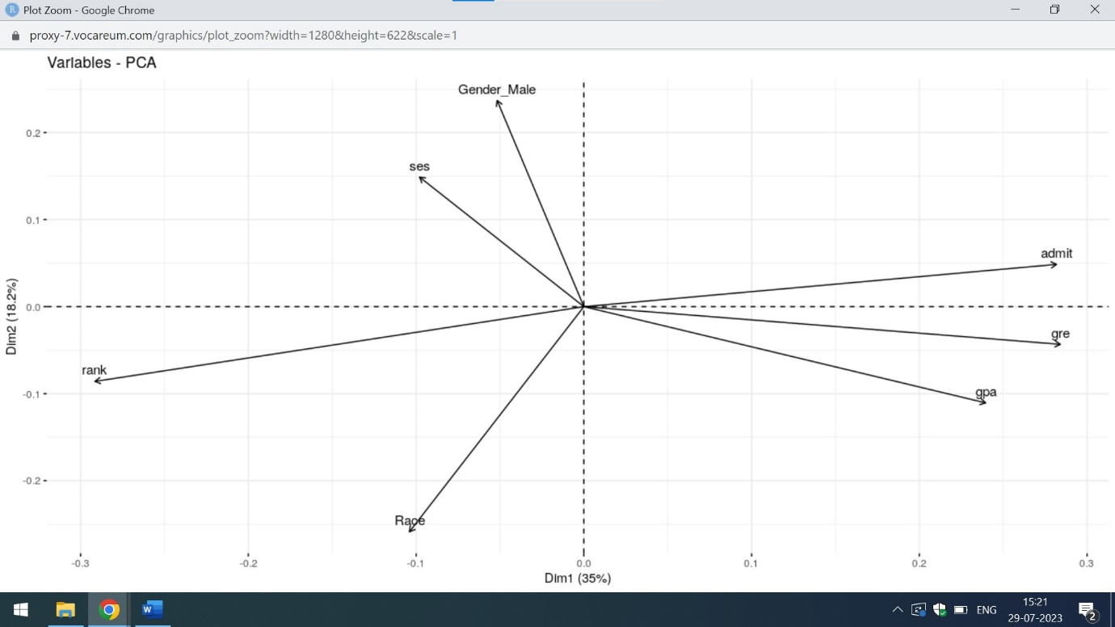

The above attached is the biplot of the attributes which gives the information of the variables of the dataset.

From the above mention screenshot,it is clear that admit is the most important variable of the college data set and have the highest value in the loading matrix followed by gre and gpa.

Q7) Run logistic model to determine the factors that influence the admission process of a student (Drop insignificant variables)

Ans) For analysing the factors that influence the admission process of a student,I am using the concept of Simple Linear Regression with Multiple variables. Below attached is the code in R

print("College Admission")

college_data<-read.csv("https://raw.githubusercontent.com/shivanipriya89/College/main/College.csv")

print(college_data)

View(college_data)

admission<-lm(formula=admit~gre+gpa+ses+Gender_Male+Race+rank,data=college_data)

print(admission)

# Dropping the columns

select(college_data,-c("ses","Gender_Male","Race"))

Below attached are the output of simple Linear Regression

admission<-lm(formula=admit~gre+gpa+ses+Gender_Male+Race+rank,data=college_data)

> print(admission)

Call:

lm(formula = admit ~ gre + gpa + ses + Gender_Male + Race + rank,

data = college_data)

Coefficients:

(Intercept) gre gpa ses Gender_Male

-0.0581285 0.0004178 0.1579084 -0.0268790 -0.0317487

Race rank

-0.0335600 -0.1089262

From the above mention output of the simple Linear Regression,it is clear that major factors affecting the admission process of student are gre and gpa.As gre and gpa are the major factors affecting the admission process of the student,so I am dropping the rest of the column. Below attached is the screenshot

> select(college_data,-c("ses","Gender_Male","Race"))

admit gre gpa rank

1 0 380 3.61 3

2 1 660 3.67 3

3 1 800 4.00 1

4 1 640 3.19 4

5 0 520 2.93 4

6 1 760 3.00 2

7 1 560 2.98 1

8 0 400 3.08 2

9 1 540 3.39 3

10 0 700 3.92 2

11 0 800 4.00 4

12 0 440 3.22 1

13 1 760 4.00 1

14 0 700 3.08 2

15 1 700 4.00 1

16 0 480 3.44 3

17 0 780 3.87 4

18 0 360 2.56 3

19 0 800 3.75 2

20 1 540 3.81 1

21 0 500 3.17 3

22 1 660 3.63 2

23 0 600 2.82 4

24 0 680 3.19 4

25 1 760 3.35 2

26 1 800 3.66 1

27 1 620 3.61 1

28 1 520 3.74 4

29 1 780 3.22 2

30 0 520 3.29 1

31 0 540 3.78 4

32 0 760 3.35 3

33 0 600 3.40 3

34 1 800 4.00 3

35 0 360 3.14 1

36 0 400 3.05 2

37 0 580 3.25 1

38 0 520 2.90 3

39 1 500 3.13 2

40 1 520 2.68 3

41 0 560 2.42 2

42 1 580 3.32 2

43 1 600 3.15 2

44 0 500 3.31 3

45 0 700 2.94 2

46 1 460 3.45 3

47 1 580 3.46 2

48 0 500 2.97 4

49 0 440 2.48 4

50 0 400 3.35 3

51 0 640 3.86 3

52 0 440 3.13 4

53 0 740 3.37 4

54 1 680 3.27 2

55 0 660 3.34 3

56 1 740 4.00 3

57 0 560 3.19 3

58 0 380 2.94 3

59 0 400 3.65 2

60 0 600 2.82 4

61 1 620 3.18 2

62 0 560 3.32 4

63 0 640 3.67 3

64 1 680 3.85 3

65 0 580 4.00 3

66 0 600 3.59 2

67 0 740 3.62 4

68 0 620 3.30 1

69 0 580 3.69 1

70 0 800 3.73 1

71 0 640 4.00 3

72 0 300 2.92 4

73 0 480 3.39 4

74 0 580 4.00 2

75 0 720 3.45 4

76 0 720 4.00 3

77 0 560 3.36 3

78 1 800 4.00 3

79 0 540 3.12 1

80 1 620 4.00 1

81 0 700 2.90 4

82 0 620 3.07 2

83 0 500 2.71 2

84 0 380 2.91 4

85 1 500 3.60 3

86 0 520 2.98 2

87 0 600 3.32 2

88 0 600 3.48 2

89 0 700 3.28 1

90 1 660 4.00 2

91 0 700 3.83 2

92 1 720 3.64 1

93 0 800 3.90 2

94 0 580 2.93 2

95 1 660 3.44 2

96 0 660 3.33 2

97 0 640 3.52 4

98 0 480 3.57 2

99 0 700 2.88 2

100 0 400 3.31 3

101 0 340 3.15 3

102 0 580 3.57 3

103 0 380 3.33 4

104 0 540 3.94 3

105 1 660 3.95 2

106 1 740 2.97 2

107 1 700 3.56 1

108 0 480 3.13 2

109 0 400 2.93 3

110 0 480 3.45 2

111 0 680 3.08 4

112 0 420 3.41 4

113 0 360 3.00 3

114 0 600 3.22 1

115 0 720 3.84 3

116 0 620 3.99 3

117 1 440 3.45 2

118 0 700 3.72 2

119 1 800 3.70 1

120 0 340 2.92 3

121 1 520 3.74 2

122 1 480 2.67 2

123 0 520 2.85 3

124 0 500 2.98 3

125 0 720 3.88 3

126 0 540 3.38 4

127 1 600 3.54 1

128 0 740 3.74 4

129 0 540 3.19 2

130 0 460 3.15 4

131 1 620 3.17 2

132 0 640 2.79 2

133 0 580 3.40 2

134 0 500 3.08 3

135 0 560 2.95 2

136 0 500 3.57 3

137 0 560 3.33 4

138 0 700 4.00 3

139 0 620 3.40 2

140 1 600 3.58 1

141 0 640 3.93 2

142 1 700 3.52 4

143 0 620 3.94 4

144 0 580 3.40 3

145 0 580 3.40 4

146 0 380 3.43 3

147 0 480 3.40 2

148 0 560 2.71 3

149 1 480 2.91 1

150 0 740 3.31 1

151 1 800 3.74 1

152 0 400 3.38 2

153 1 640 3.94 2

154 0 580 3.46 3

155 0 620 3.69 3

156 1 580 2.86 4

157 0 560 2.52 2

158 1 480 3.58 1

159 0 660 3.49 2

160 0 700 3.82 3

161 0 600 3.13 2

162 0 640 3.50 2

163 1 700 3.56 2

164 0 520 2.73 2

165 0 580 3.30 2

166 0 700 4.00 1

167 0 440 3.24 4

168 0 720 3.77 3

169 0 500 4.00 3

170 0 600 3.62 3

171 0 400 3.51 3

172 0 540 2.81 3

173 0 680 3.48 3

174 1 800 3.43 2

175 0 500 3.53 4

176 1 620 3.37 2

177 0 520 2.62 2

178 1 620 3.23 3

179 0 620 3.33 3

180 0 300 3.01 3

181 0 620 3.78 3

182 0 500 3.88 4

183 0 700 4.00 2

184 1 540 3.84 2

185 0 500 2.79 4

186 0 800 3.60 2

187 0 560 3.61 3

188 0 580 2.88 2

189 0 560 3.07 2

190 0 500 3.35 2

191 1 640 2.94 2

192 0 800 3.54 3

193 0 640 3.76 3

194 0 380 3.59 4

195 1 600 3.47 2

196 0 560 3.59 2

197 0 660 3.07 3

198 1 400 3.23 4

199 0 600 3.63 3

200 0 580 3.77 4

201 0 800 3.31 3

202 1 580 3.20 2

203 1 700 4.00 1

204 0 420 3.92 4

205 1 600 3.89 1

206 1 780 3.80 3

207 0 740 3.54 1

208 1 640 3.63 1

209 0 540 3.16 3

210 0 580 3.50 2

211 0 740 3.34 4

212 0 580 3.02 2

213 0 460 2.87 2

214 0 640 3.38 3

215 1 600 3.56 2

216 1 660 2.91 3

217 0 340 2.90 1

218 1 460 3.64 1

219 0 460 2.98 1

220 1 560 3.59 2

221 0 540 3.28 3

222 0 680 3.99 3

223 1 480 3.02 1

224 0 800 3.47 3

225 0 800 2.90 2

226 1 720 3.50 3

227 0 620 3.58 2

228 0 540 3.02 4

229 0 480 3.43 2

230 1 720 3.42 2

231 0 580 3.29 4

232 0 600 3.28 3

233 0 380 3.38 2

234 0 420 2.67 3

235 1 800 3.53 1

236 0 620 3.05 2

237 1 660 3.49 2

238 0 480 4.00 2

239 0 500 2.86 4

240 0 700 3.45 3

241 0 440 2.76 2

242 1 520 3.81 1

243 1 680 2.96 3

244 0 620 3.22 2

245 0 540 3.04 1

246 0 800 3.91 3

247 0 680 3.34 2

248 0 440 3.17 2

249 0 680 3.64 3

250 0 640 3.73 3

[ reached 'max' / getOption("max.print") -- omitted 150 rows ]

Q8) Calculate the accuracy of the model and run validation techniques.

Ans) For determining the accuracy of the model,I am using the concept of K-Fold Cross Validation. Below attached is the code in R

# K-Fold Cross Validation

college_data<-read.csv("https://raw.githubusercontent.com/shivanipriya89/College/main/College.csv")

print(college_data)

View(college_data)

str(college_data)

# Convert admit to factor

college_data$admit<-sapply(college_data$admit,factor)

# Define Training Control

mytraining<-trainControl(method="cv",number=10)

# Fix the Parameters of the Algorithm

grid<-expand.grid(.fL = c(0), .usekernel = c(FALSE),.adjust = 0.5 )

# train the model

model<-train(admit ~., data = college_data, trControl = mytraining, method = 'nb', tuneGrid = grid)

print(model)

|  |
| --- |
| > print(model)  Naive Bayes  400 samples  6 predictor  2 classes: '0', '1'  No pre-processing  Resampling: Cross-Validated (10 fold)  Summary of sample sizes: 360, 360, 360, 359, 360, 360, ...  Resampling results:  Accuracy Kappa  0.6751517 0.13692  Tuning parameter 'fL' was held constant at a value of 0  Tuning  parameter 'usekernel' was held constant at a value of FALSE  Tuning parameter 'adjust' was held constant at a value of 0.5 |
|  |
| |  | | --- | | > | |

The above mention is the output of the K-Fold Cross Validation. The accuracy of this model is around 68%(approx.)

Q9) Try other modelling techniques like decision tree and SVM and select a champion model

Ans) Below attached is the code in R which gives an overview of the decision tree and SVM

# Decision Tree

college_data<-read.csv("https://raw.githubusercontent.com/shivanipriya89/College/main/College.csv")

print(college_data)

View(college_data)

str(college_data)

# Convert admit to factor

college_data$admit<-sapply(college_data$admit,factor)

str(college_data)

# Building the mode

college_model<-rpart(admit~.,data=college_data,method="class")

college_model

printcp(college_model)

plotcp(college_model)

summary(college_model)

# Support Vector Machine

college_data<-read.csv("https://raw.githubusercontent.com/shivanipriya89/College/main/College.csv")

print(college_data)

View(college_data)

str(college_data)

# Convert admit to factor

college_data$admit<-sapply(college_data$admit,factor)

str(college_data)

# Spliting the data

sample_split<-floor(0.7*nrow(college_data))

set.seed(1)

training<-sample(seq_len(nrow(college_data)),size=sample_split)

# Training and testing Data

mytraining<-college_data[training,]

mytesting<-college_data[-training,]

# Support Vector Machine

support_vector<-svm(admit~.,mytraining)

confusionMatrix(mytraining$admit,predict(support_vector),positive='1')

The output of the Decision Tree and SVM are mention below:

library(rpart)

> college_model<-rpart(admit~.,data=college_data,method="class")

> college_model

n= 400

node), split, n, loss, yval, (yprob)

* denotes terminal node

1) root 400 127 0 (0.6825000 0.3175000)

2) gpa< 3.415 208 45 0 (0.7836538 0.2163462)

4) rank>=2.5 99 13 0 (0.8686869 0.1313131) *

5) rank< 2.5 109 32 0 (0.7064220 0.2935780)

10) gre< 730 99 25 0 (0.7474747 0.2525253) *

11) gre>=730 10 3 1 (0.3000000 0.7000000) *

3) gpa>=3.415 192 82 0 (0.5729167 0.4270833)

6) rank>=1.5 160 58 0 (0.6375000 0.3625000)

12) rank>=2.5 89 27 0 (0.6966292 0.3033708) *

13) rank< 2.5 71 31 0 (0.5633803 0.4366197)

26) gpa>=3.495 55 20 0 (0.6363636 0.3636364)

52) gpa< 3.73 26 5 0 (0.8076923 0.1923077) *

53) gpa>=3.73 29 14 1 (0.4827586 0.5172414)

106) Race>=1.5 19 8 0 (0.5789474 0.4210526) *

107) Race< 1.5 10 3 1 (0.3000000 0.7000000) *

27) gpa< 3.495 16 5 1 (0.3125000 0.6875000) *

7) rank< 1.5 32 8 1 (0.2500000 0.7500000) *

|  |
| --- |
| rpart(formula = admit ~ ., data = college_data, method = "class")  Variables actually used in tree construction:  [1] gpa gre Race rank  Root node error: 127/400 = 0.3175  n= 400  CP nsplit rel error xerror xstd  1 0.062992 0 1.00000 1.00000 0.073308  2 0.023622 2 0.87402 0.87402 0.070514  3 0.015748 4 0.82677 0.92126 0.071639  4 0.010000 8 0.76378 0.98425 0.072994 |
|  |
| |  | | --- | | > | |

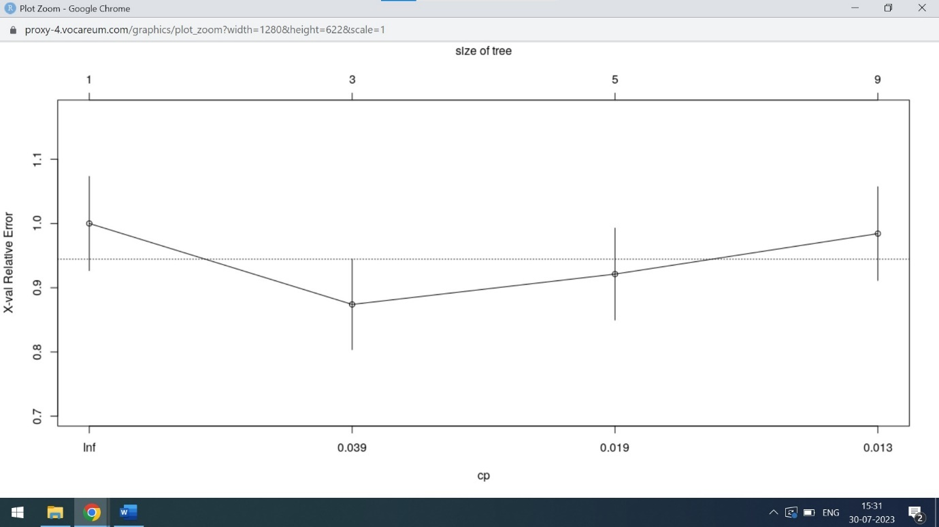

It is clear from the decision tree of College Admissions ie the relative error first decreases and then increases when the size of the tree increases.

summary(college_model)

Call:

rpart(formula = admit ~ ., data = college_data, method = "class")

n= 400

CP nsplit rel error xerror xstd

1 0.06299213 0 1.0000000 1.0000000 0.07330768

2 0.02362205 2 0.8740157 0.8740157 0.07051422

3 0.01574803 4 0.8267717 0.9212598 0.07163948

4 0.01000000 8 0.7637795 0.9842520 0.07299408

Variable importance

gpa rank gre Race ses

41 34 19 5 1

Node number 1: 400 observations, complexity param=0.06299213

predicted class=0 expected loss=0.3175 P(node) =1

class counts: 273 127

probabilities: 0.682 0.318

left son=2 (208 obs) right son=3 (192 obs)

Primary splits:

gpa < 3.415 to the left, improve=8.8678210, (0 missing)

rank < 2.5 to the right, improve=7.7819370, (0 missing)

gre < 510 to the left, improve=4.8439760, (0 missing)

Race < 1.5 to the right, improve=1.2564990, (0 missing)

ses < 1.5 to the right, improve=0.3782926, (0 missing)

Surrogate splits:

gre < 610 to the left, agree=0.645, adj=0.260, (0 split)

Race < 2.5 to the left, agree=0.545, adj=0.052, (0 split)

rank < 1.5 to the right, agree=0.528, adj=0.016, (0 split)

Node number 2: 208 observations, complexity param=0.01574803

predicted class=0 expected loss=0.2163462 P(node) =0.52

class counts: 163 45

probabilities: 0.784 0.216

left son=4 (99 obs) right son=5 (109 obs)

Primary splits:

rank < 2.5 to the right, improve=2.731978, (0 missing)

gre < 750 to the left, improve=2.515925, (0 missing)

ses < 2.5 to the right, improve=1.524154, (0 missing)

Race < 1.5 to the right, improve=1.390400, (0 missing)

gpa < 3.235 to the right, improve=1.053296, (0 missing)

Surrogate splits:

gre < 530 to the left, agree=0.582, adj=0.121, (0 split)

gpa < 3.225 to the right, agree=0.553, adj=0.061, (0 split)

ses < 2.5 to the right, agree=0.548, adj=0.051, (0 split)

Gender_Male < 0.5 to the left, agree=0.534, adj=0.020, (0 split)

Node number 3: 192 observations, complexity param=0.06299213

predicted class=0 expected loss=0.4270833 P(node) =0.48

class counts: 110 82

probabilities: 0.573 0.427

left son=6 (160 obs) right son=7 (32 obs)

Primary splits:

rank < 1.5 to the right, improve=8.0083330, (0 missing)

gre < 450 to the left, improve=1.1737770, (0 missing)

ses < 2.5 to the left, improve=0.5522727, (0 missing)

gpa < 3.945 to the left, improve=0.5037879, (0 missing)

Gender_Male < 0.5 to the right, improve=0.4942810, (0 missing)

Node number 4: 99 observations

predicted class=0 expected loss=0.1313131 P(node) =0.2475

class counts: 86 13

probabilities: 0.869 0.131

Node number 5: 109 observations, complexity param=0.01574803

predicted class=0 expected loss=0.293578 P(node) =0.2725

class counts: 77 32

probabilities: 0.706 0.294

left son=10 (99 obs) right son=11 (10 obs)

Primary splits:

gre < 730 to the left, improve=3.63727200, (0 missing)

Race < 1.5 to the right, improve=1.22822600, (0 missing)

ses < 2.5 to the right, improve=1.01945100, (0 missing)

gpa < 2.905 to the left, improve=0.33841060, (0 missing)

rank < 1.5 to the right, improve=0.02221607, (0 missing)

Node number 6: 160 observations, complexity param=0.02362205

predicted class=0 expected loss=0.3625 P(node) =0.4

class counts: 102 58

probabilities: 0.637 0.362

left son=12 (89 obs) right son=13 (71 obs)

Primary splits:

rank < 2.5 to the right, improve=1.4024450, (0 missing)

gre < 650 to the left, improve=1.1404990, (0 missing)

gpa < 3.945 to the left, improve=0.7032468, (0 missing)

Gender_Male < 0.5 to the right, improve=0.1831404, (0 missing)

Race < 1.5 to the right, improve=0.1587912, (0 missing)

Surrogate splits:

gpa < 3.515 to the right, agree=0.594, adj=0.085, (0 split)

Node number 7: 32 observations

predicted class=1 expected loss=0.25 P(node) =0.08

class counts: 8 24

probabilities: 0.250 0.750

Node number 10: 99 observations

predicted class=0 expected loss=0.2525253 P(node) =0.2475

class counts: 74 25

probabilities: 0.747 0.253

Node number 11: 10 observations

predicted class=1 expected loss=0.3 P(node) =0.025

class counts: 3 7

probabilities: 0.300 0.700

Node number 12: 89 observations

predicted class=0 expected loss=0.3033708 P(node) =0.2225

class counts: 62 27

probabilities: 0.697 0.303

Node number 13: 71 observations, complexity param=0.02362205

predicted class=0 expected loss=0.4366197 P(node) =0.1775

class counts: 40 31

probabilities: 0.563 0.437

left son=26 (55 obs) right son=27 (16 obs)

Primary splits:

gpa < 3.495 to the right, improve=2.6000320, (0 missing)

gre < 500 to the left, improve=1.7510060, (0 missing)

Gender_Male < 0.5 to the right, improve=0.8327521, (0 missing)

ses < 2.5 to the left, improve=0.8001448, (0 missing)

Race < 2.5 to the left, improve=0.1452296, (0 missing)

Node number 26: 55 observations, complexity param=0.01574803

predicted class=0 expected loss=0.3636364 P(node) =0.1375

class counts: 35 20

probabilities: 0.636 0.364

left son=52 (26 obs) right son=53 (29 obs)

Primary splits:

gpa < 3.73 to the left, improve=2.8948640, (0 missing)

Gender_Male < 0.5 to the right, improve=1.2412120, (0 missing)

ses < 2.5 to the left, improve=0.7030835, (0 missing)

gre < 690 to the right, improve=0.3878788, (0 missing)

Race < 1.5 to the right, improve=0.1515152, (0 missing)

Surrogate splits:

gre < 610 to the left, agree=0.582, adj=0.115, (0 split)

Race < 1.5 to the left, agree=0.564, adj=0.077, (0 split)

ses < 2.5 to the right, agree=0.545, adj=0.038, (0 split)

Node number 27: 16 observations

predicted class=1 expected loss=0.3125 P(node) =0.04

class counts: 5 11

probabilities: 0.312 0.688

Node number 52: 26 observations

predicted class=0 expected loss=0.1923077 P(node) =0.065

class counts: 21 5

probabilities: 0.808 0.192

Node number 53: 29 observations, complexity param=0.01574803

predicted class=1 expected loss=0.4827586 P(node) =0.0725

class counts: 14 15

probabilities: 0.483 0.517

left son=106 (19 obs) right son=107 (10 obs)

Primary splits:

Race < 1.5 to the right, improve=1.0196010, (0 missing)

gre < 690 to the right, improve=0.8827586, (0 missing)

ses < 2.5 to the left, improve=0.5827586, (0 missing)

gpa < 3.945 to the left, improve=0.5029606, (0 missing)

Gender_Male < 0.5 to the right, improve=0.4539125, (0 missing)

Surrogate splits:

ses < 2.5 to the left, agree=0.69, adj=0.1, (0 split)

Node number 106: 19 observations

predicted class=0 expected loss=0.4210526 P(node) =0.0475

class counts: 11 8

probabilities: 0.579 0.421

Node number 107: 10 observations

predicted class=1 expected loss=0.3 P(node) =0.025

class counts: 3 7

probabilities: 0.300 0.700

It is clear from the summary of the college data set ie gpa and rank are the two most important variables of the dataset for decision making

support_vector<-svm(admit~.,mytraining)

> confusionMatrix(mytraining$admit,predict(support_vector),positive='1')

Confusion Matrix and Statistics

Reference

Prediction 0 1

0 183 5

1 71 21

Accuracy : 0.7286

95% CI : (0.6725, 0.7798)

No Information Rate : 0.9071

P-Value [Acc > NIR] : 1

Kappa : 0.2469

Mcnemar's Test P-Value : 8.918e-14

Sensitivity : 0.80769

Specificity : 0.72047

Pos Pred Value : 0.22826

Neg Pred Value : 0.97340

Prevalence : 0.09286

Detection Rate : 0.07500

Detection Prevalence : 0.32857

Balanced Accuracy : 0.76408

'Positive' Class : 1

From the Support Vector Machine Algorithm(SVM),it is clear that important variable for tree construction or in decision making are gpa,gre,Race and rank. The accuracy result of SVM is 73%(approx.).Hence,it is suitable to opt for SVM for decision making

Q10) Determine the accuracy rates for each kind of model

Ans) The various modelling techniques which I am using to analyse the admission process of the student are Boostrap,K-Fold Cross Validation and Repeated K-Fold Cross Validation. Below mention is the code in R for modelling techniques

# Boostrap

college_data<-read.csv("https://raw.githubusercontent.com/shivanipriya89/College/main/College.csv")

print(college_data)

View(college_data)

# Convert admit to factor

college_data$admit<-sapply(college_data$admit,factor)

# Define Training

train_control<-trainControl(method = 'boot', number = 100)

# train the model

model<-train(admit ~., data = college_data, trControl = train_control, method = 'nb')

print(model)

# K-Fold Cross Validation

college_data<-read.csv("https://raw.githubusercontent.com/shivanipriya89/College/main/College.csv")

print(college_data)

View(college_data)

str(college_data)

# Convert admit to factor

college_data$admit<-sapply(college_data$admit,factor)

# Define Training Control

mytraining<-trainControl(method="cv",number=10)

# Fix the Parameters of the Algorithm

grid<-expand.grid(.fL = c(0), .usekernel = c(FALSE),.adjust = 0.5 )

# train the model

model<-train(admit ~., data = college_data, trControl = mytraining, method = 'nb', tuneGrid = grid)

print(model)

# Repeated K-Fold Cross Validation

college_data<-read.csv("https://raw.githubusercontent.com/shivanipriya89/College/main/College.csv")

print(college_data)

View(college_data)

college_data$admit<-sapply(college_data$admit,factor)

# Define the Training Control

train_control<-trainControl(method="repeatedcv",number=10,repeats = 3)

model<-train(admit~.,data=college_data,trControl=train_control,method='nb')

print(model)

The output of Boostrap,K-Fold and Repeated K-Fold Cross Validation techniques are mention below:

> model<-train(admit ~., data = college_data, trControl = train_control, method = 'nb')

> print(model)

Naive Bayes

400 samples

6 predictor

2 classes: '0', '1'

No pre-processing

Resampling: Bootstrapped (100 reps)

Summary of sample sizes: 400, 400, 400, 400, 400, 400, ...

Resampling results across tuning parameters:

usekernel Accuracy Kappa

FALSE 0.6817573 0.17467431

TRUE 0.6883763 0.07976111

Tuning parameter 'fL' was held constant at a value of 0

Tuning

parameter 'adjust' was held constant at a value of 1

Accuracy was used to select the optimal model using the largest value.

The final values used for the model were fL = 0, usekernel = TRUE

and adjust = 1.

The accuracy result of Boostrap model is 69% (approx.)

|  |
| --- |
| print(model)  Naive Bayes  400 samples  6 predictor  2 classes: '0', '1'  No pre-processing  Resampling: Cross-Validated (10 fold)  Summary of sample sizes: 359, 360, 360, 360, 360, 360, ...  Resampling results:  Accuracy Kappa  0.690358 0.1804949  Tuning parameter 'fL' was held constant at a value of 0  Tuning  parameter 'usekernel' was held constant at a value of FALSE  Tuning parameter 'adjust' was held constant at a value of 0.5 |
|  |
| |  | | --- | | > | |

The accuracy result of K-Fold cross validation is 69%(approx.)

print(model)

Naive Bayes

400 samples

6 predictor

2 classes: '0', '1'

No pre-processing

Resampling: Cross-Validated (10 fold, repeated 3 times)

Summary of sample sizes: 360, 360, 360, 361, 359, 360, ...

Resampling results across tuning parameters:

usekernel Accuracy Kappa

FALSE 0.6852319 0.16618787

TRUE 0.6908417 0.05981299

Tuning parameter 'fL' was held constant at a value of 0

Tuning

parameter 'adjust' was held constant at a value of 1

Accuracy was used to select the optimal model using the largest value.

The final values used for the model were fL = 0, usekernel = TRUE

and adjust = 1.

The accuracy result of repeated K-Fold cross validation is 69%(approx). From the above mention data,it is clear that probability that student will not take admission is 68.5% and student will take admission is 69%

Q11) Select the most accurate model

Ans) The most accurate model is Support Vector Machine(SVM). It’s accuracy result is 73% (approx.). Below mention is the code and output of SVM

# Support Vector Machine

college_data<-read.csv("https://raw.githubusercontent.com/shivanipriya89/College/main/College.csv")

print(college_data)

View(college_data)

str(college_data)

# Convert admit to factor

college_data$admit<-sapply(college_data$admit,factor)

str(college_data)

# Spliting the data

sample_split<-floor(0.7*nrow(college_data))

set.seed(1)

training<-sample(seq_len(nrow(college_data)),size=sample_split)

# Training and testing Data

mytraining<-college_data[training,]

mytesting<-college_data[-training,]

# Support Vector Machine

support_vector<-svm(admit~.,mytraining)

confusionMatrix(mytraining$admit,predict(support_vector),positive='1')

|  |
| --- |
| confusionMatrix(mytraining$admit,predict(support_vector),positive='1')  Confusion Matrix and Statistics  Reference  Prediction 0 1  0 183 5  1 71 21    Accuracy : 0.7286  95% CI : (0.6725, 0.7798)  No Information Rate : 0.9071  P-Value [Acc > NIR] : 1    Kappa : 0.2469    Mcnemar's Test P-Value : 8.918e-14    Sensitivity : 0.80769  Specificity : 0.72047  Pos Pred Value : 0.22826  Neg Pred Value : 0.97340  Prevalence : 0.09286  Detection Rate : 0.07500  Detection Prevalence : 0.32857  Balanced Accuracy : 0.76408    'Positive' Class : 1 |
|  |
| |  | | --- | | > | |

It is clear from the above attached screenshot of SVM ie the accuracy result of this model is 73%(approx.). Hence,from the above mention models, SVM gives the highest accuracy results

Q12) Identify other Machine learning or statistical techniques

Ans) Naïve Bayes and Leave one out Cross Validation are some of the other Machine Learning and Statistical techniques. Below attached is the code in R

# Naive Bays Model

college_data<-read.csv("https://raw.githubusercontent.com/shivanipriya89/College/main/College.csv")

print(college_data)

View(college_data)

str(college_data)

# Use the Naive Bays Algorithim

mycollege<-naiveBayes(admit~.,data=college_data)

mycollege

summary(mycollege)

# Leave one out cross validation

college_data<-read.csv("https://raw.githubusercontent.com/shivanipriya89/College/main/College.csv")

print(college_data)

View(college_data)

college_data$admit<-sapply(college_data$admit,factor)

# Define Train Control

train_control=trainControl(method='LOOCV')

model<-train(admit~.,data=college_data,trControl=train_control,method="nb")

print(model)

The output of both the models are mention below:

|  |
| --- |
| > mycollege  Naive Bayes Classifier for Discrete Predictors  Call:  naiveBayes.default(x = X, y = Y, laplace = laplace)  A-priori probabilities:  Y  0 1  0.6825 0.3175  Conditional probabilities:  gre  Y [,1] [,2]  0 573.1868 115.8302  1 618.8976 108.8849  gpa  Y [,1] [,2]  0 3.343700 0.3771330  1 3.489213 0.3701771  ses  Y [,1] [,2]  0 2.018315 0.8064730  1 1.937008 0.8140437  Gender_Male  Y [,1] [,2]  0 0.4835165 0.5006460  1 0.4566929 0.5000937  Race  Y [,1] [,2]  0 1.996337 0.8112181  1 1.889764 0.8472959  rank  Y [,1] [,2]  0 2.641026 0.9171978  1 2.149606 0.9178887 |
|  |
| |  | | --- | | > | |

The apriori probabilities of naïve Bayes is mention above

|  |
| --- |
| print(model)  Naive Bayes  400 samples  6 predictor  2 classes: '0', '1'  No pre-processing  Resampling: Leave-One-Out Cross-Validation  Summary of sample sizes: 399, 399, 399, 399, 399, 399, ...  Resampling results across tuning parameters:  usekernel Accuracy Kappa  FALSE 0.69 0.17730967  TRUE 0.69 0.05354349  Tuning parameter 'fL' was held constant at a value of 0  Tuning  parameter 'adjust' was held constant at a value of 1  Accuracy was used to select the optimal model using the largest value.  The final values used for the model were fL = 0, usekernel = FALSE  and adjust = 1. |
|  |
| |  | | --- | | > | |

The output of the Leave-one out cross validation is mention above. The accuracy result of Naïve Bayes is 69% approx.

Q13) Categorize the average of grade point into High, Medium, and Low (with admission probability percentages) and plot it on a point chart.    
Cross grid for admission variables with GRE Categorization is shown below:

Ans) The below mention is the code in R which analyses the average point of grade in various categories

college_data<-read.csv("https://raw.githubusercontent.com/shivanipriya89/College/main/College.csv")

print(college_data)

View(college_data)

str(college_data)

print(college_data$gre)

max(college_data$gre)

min(college_data$gre)

college_analysis<-transform(college_data,Categorized=ifelse(gre<441,"Low",ifelse(gre<581,"Medium","High")))

print(college_analysis)

print(college_data$gre,college_data$college_analysis)

summary(college_analysis)

|  |
| --- |
| print(college_analysis)  admit gre gpa ses Gender_Male Race rank Categorized  1 0 380 3.61 1 0 3 3 Low  2 1 660 3.67 2 0 2 3 High  3 1 800 4.00 2 0 2 1 High  4 1 640 3.19 1 1 2 4 High  5 0 520 2.93 3 1 2 4 Medium  6 1 760 3.00 2 1 1 2 High  7 1 560 2.98 2 1 2 1 Medium  8 0 400 3.08 2 0 2 2 Low  9 1 540 3.39 1 1 1 3 Medium  10 0 700 3.92 1 0 2 2 High  11 0 800 4.00 1 1 1 4 High  12 0 440 3.22 3 0 2 1 Low  13 1 760 4.00 3 1 2 1 High  14 0 700 3.08 2 0 2 2 High  15 1 700 4.00 2 1 1 1 High  16 0 480 3.44 3 0 1 3 Medium  17 0 780 3.87 2 0 3 4 High  18 0 360 2.56 3 1 3 3 Low  19 0 800 3.75 1 1 3 2 High  20 1 540 3.81 1 0 3 1 Medium  21 0 500 3.17 3 0 2 3 Medium  22 1 660 3.63 1 0 1 2 High  23 0 600 2.82 1 0 3 4 High  24 0 680 3.19 1 0 1 4 High  25 1 760 3.35 2 0 2 2 High  26 1 800 3.66 2 1 1 1 High  27 1 620 3.61 2 0 1 1 High  28 1 520 3.74 2 0 3 4 Medium  29 1 780 3.22 1 0 1 2 High  30 0 520 3.29 1 0 1 1 Medium  31 0 540 3.78 1 1 1 4 Medium  32 0 760 3.35 2 1 1 3 High  33 0 600 3.40 3 0 1 3 High  34 1 800 4.00 3 0 1 3 High  35 0 360 3.14 1 1 2 1 Low  36 0 400 3.05 3 0 2 2 Low  37 0 580 3.25 1 0 2 1 Medium  38 0 520 2.90 2 0 2 3 Medium  39 1 500 3.13 2 0 2 2 Medium  40 1 520 2.68 2 0 1 3 Medium  41 0 560 2.42 1 1 3 2 Medium  42 1 580 3.32 1 0 1 2 Medium  43 1 600 3.15 2 1 1 2 High  44 0 500 3.31 2 0 2 3 Medium  45 0 700 2.94 1 0 3 2 High  46 1 460 3.45 2 1 3 3 Medium  47 1 580 3.46 3 1 1 2 Medium  48 0 500 2.97 3 0 2 4 Medium  49 0 440 2.48 3 0 3 4 Low  50 0 400 3.35 3 0 1 3 Low  51 0 640 3.86 2 1 3 3 High  52 0 440 3.13 2 0 2 4 Low  53 0 740 3.37 2 1 3 4 High  54 1 680 3.27 2 0 2 2 High  55 0 660 3.34 1 0 1 3 High  56 1 740 4.00 1 1 2 3 High  57 0 560 3.19 3 1 1 3 Medium  58 0 380 2.94 3 0 2 3 Low  59 0 400 3.65 3 1 2 2 Low  60 0 600 2.82 3 1 1 4 High  61 1 620 3.18 2 1 1 2 High  62 0 560 3.32 1 0 3 4 Medium  63 0 640 3.67 1 1 2 3 High  64 1 680 3.85 1 1 3 3 High  65 0 580 4.00 2 1 3 3 Medium  66 0 600 3.59 1 0 1 2 High  67 0 740 3.62 3 1 2 4 High  68 0 620 3.30 2 1 3 1 High  69 0 580 3.69 3 0 3 1 Medium  70 0 800 3.73 1 1 1 1 High  71 0 640 4.00 1 1 1 3 High  72 0 300 2.92 1 1 1 4 Low  73 0 480 3.39 2 0 2 4 Medium  74 0 580 4.00 3 0 3 2 Medium  75 0 720 3.45 2 1 2 4 High  76 0 720 4.00 2 0 3 3 High  77 0 560 3.36 1 1 2 3 Medium  78 1 800 4.00 3 0 3 3 High  79 0 540 3.12 3 1 2 1 Medium  80 1 620 4.00 2 0 2 1 High  81 0 700 2.90 2 0 2 4 High  82 0 620 3.07 3 1 2 2 High  83 0 500 2.71 2 0 3 2 Medium  84 0 380 2.91 3 1 2 4 Low  85 1 500 3.60 1 1 1 3 Medium  86 0 520 2.98 2 0 2 2 Medium  87 0 600 3.32 1 0 3 2 High  88 0 600 3.48 1 0 1 2 High  89 0 700 3.28 3 0 3 1 High  90 1 660 4.00 1 1 1 2 High  91 0 700 3.83 2 0 2 2 High  92 1 720 3.64 2 0 2 1 High  93 0 800 3.90 3 1 1 2 High  94 0 580 2.93 3 1 1 2 Medium  95 1 660 3.44 2 0 3 2 High  96 0 660 3.33 2 1 3 2 High  97 0 640 3.52 2 1 3 4 High  98 0 480 3.57 3 1 2 2 Medium  99 0 700 2.88 2 1 3 2 High  100 0 400 3.31 3 1 2 3 Low  101 0 340 3.15 2 0 1 3 Low  102 0 580 3.57 1 1 2 3 Medium  103 0 380 3.33 3 0 3 4 Low  104 0 540 3.94 3 0 1 3 Medium  105 1 660 3.95 2 1 1 2 High  106 1 740 2.97 1 1 1 2 High  107 1 700 3.56 1 1 2 1 High  108 0 480 3.13 2 0 1 2 Medium  109 0 400 2.93 1 1 3 3 Low  110 0 480 3.45 3 0 1 2 Medium  111 0 680 3.08 3 0 3 4 High  112 0 420 3.41 2 1 3 4 Low  113 0 360 3.00 1 0 1 3 Low  114 0 600 3.22 3 1 2 1 High  115 0 720 3.84 1 1 2 3 High  116 0 620 3.99 2 1 2 3 High  117 1 440 3.45 1 1 3 2 Low  118 0 700 3.72 2 1 2 2 High  119 1 800 3.70 1 0 2 1 High  120 0 340 2.92 3 1 2 3 Low  121 1 520 3.74 2 0 2 2 Medium  122 1 480 2.67 1 0 1 2 Medium  123 0 520 2.85 3 0 1 3 Medium  124 0 500 2.98 3 0 2 3 Medium  125 0 720 3.88 2 0 3 3 High  [ reached 'max' / getOption("max.print") -- omitted 275 rows ] |
|  |
| |  | | --- | | > | |

The above mention screenshot has a new column Categorized with values Low,Medium and High in it wrt GRE

Click on this

<https://github.com/shivanipriya89/College/blob/main/College.csv>

link for viewing the tabular format of College Admission Data

This <https://raw.githubusercontent.com/shivanipriya89/College/main/College.csv>

Link has the csv file for analysis